Edwin Albert Speicher
May 23, 1885 – July 7, 1965

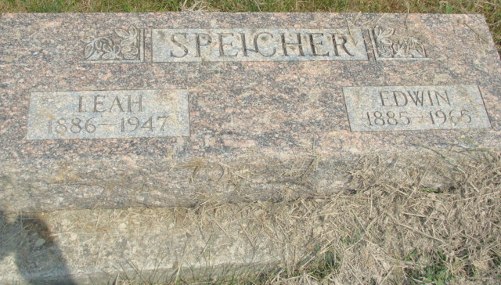
Photo by Alicia Kneuss

Indiana, Death Certificates, 1899-2011
Name: Edwin A Speicher
Gender: Male
Race: White
Age: 80
Marital status: Widowed
Birth Date: 23 May 1885
Birth Place: Indiana
Death Date: 7 Jul 1965
Death Place: Geneva, Adams, Indiana, USA
Death Registration Date: 1965
Father: William Speicher
Mother: Rossetta Gerber
Informant: Carl Speicher, son
Burial: MRE; 7/9/1965

