Daniel Robert Speicher
June 4, 1910 – April 3, 2001

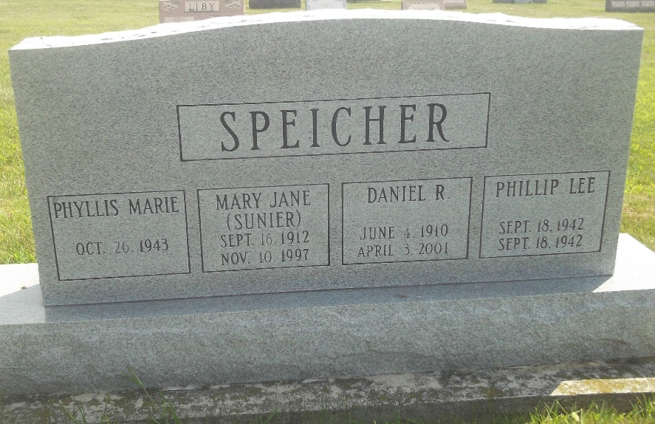
Photo by DSON1492

Daniel R. Speicher, 90, of Berne, owner/operator of Moore's Store, which later became Speicher's Electronics, until 1979, died Tuesday, April 3, 2001, at Swiss Village. The Adams County native had worked at General Electric Co. in Decatur as a draftsman and worked in his shop at home until age 87, repairing motors and blowers. He was a member of Cross United Church of Christ and Lions Club.
Surviving are a son, Edward W. of Palmdale, Calif.; a daughter, Phyllis M. Speicher of Crown Point; and a sister, Barbara M. Cooley of Shorewood, Wis. He was preceded in death by his wife, Mary Jane, a brother and a sister.
Services are 10:30 a.m. Friday at Cross United Church of Christ, Berne, with calling one hour before services. Calling is also from 2 to 4 and 6:30 to 8 p.m. today at Yager-Kirchhofer Funeral Home, Berne. Burial will be at M.R.E. Cemetery, Berne. Memorials are to the church. Information provided by Yager-Kirchhofer Funeral Home, Berne.

News-Sentinel, The (Allen County, Indiana)
Thursday, April 5, 2001

