Barbara (Shinbeck) Speicher
August 27, 1881 – July 8, 1914

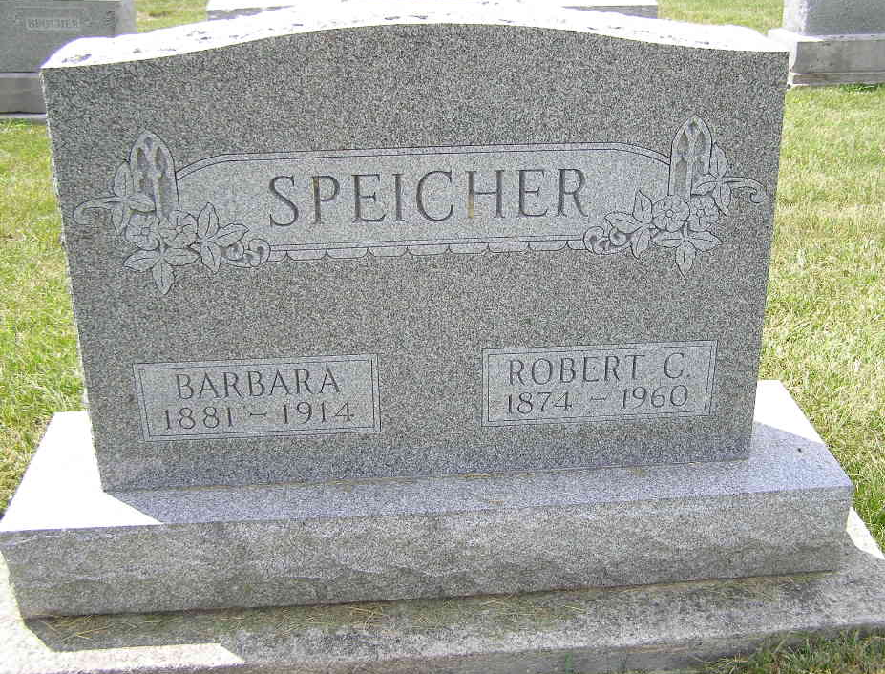
Photo by Shaunda Bedwell Opdycke
Indiana, Death Certificates, 1899-2017
Name Barbara Speicher
[Barbara Slinbeck]
Gender Female
Race White
Age 32y 10m 11d
Marital Status Married
Birth Date 27 Aug 1881
Birth Place Adams Colorado (sic-county)
Death Date 8 Jul 1914
Death Place Wabash, Adams, Indiana, USA
Death Registration Date 1910 - 1919
Father John Shinbeck
Mother Barabara Hauser
Spouse R C Speicher, informant
Burial MRE 7/10/1914
**

Biery-Yager Funeral Home Records, Adams County, Indiana
Mrs. Robert Speicher; Died July 8, 1914 Wabash Township from peronitis; Age 33 years, 10 months, 11 days; Married; Religion: Ref; Funeral July 10, 1914 Berne; Burial MRE Cemetery; Charge to Mr. Robert Speicher; Order given by Mr. Robert Speicher

