William H. Speheger
August 4, 1881 – January 15, 1915

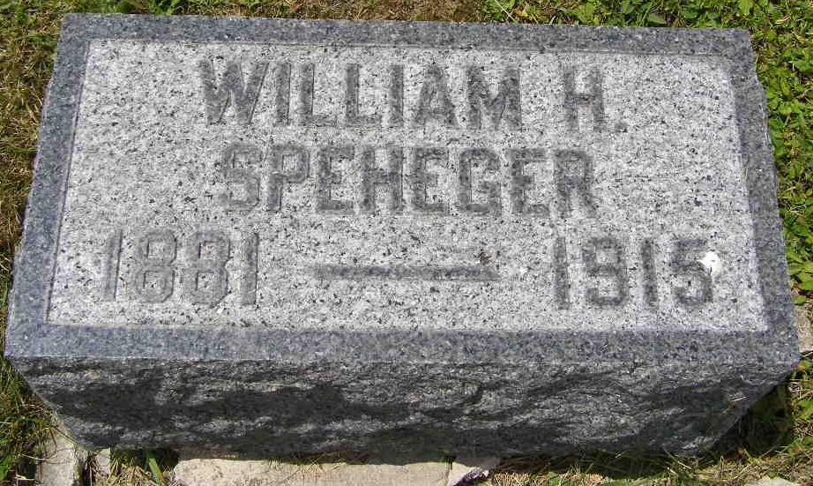
Photo by Shaunda Bedwell Opdycke

Biery-Yager Funeral Home Record, Adams County, Indiana
Will H. Specheger; Died January 15, 1915 in Nottingham Township; Age not stated; Mail carrier; Married; Religion: Christian; Funeral January 18, 1915 at Salem; Charge to Abe Specheger; Order given by Abe Specheger
(Handprinted note: Buried in MRE (from cemetery book) William H. Speheger)
**

Indiana, U.S., WPA Death Index, 1882-1920

Name William H. Speeheger
Date Jan 15, 1915
Location Wells County
Age 38 Yr
Gender Male
Race White
Source location County Health Office, Bluffton
Source notes The source of this record is the book H-18 on page 71 within the series produced by the Indiana Works Progress Administration.
**

William H Speheger from tree ROGERS Tree

Birth 4 Aug 1881 Ohio, USA
Residence 1900 Wells, Indiana, USA
Death 15 Jan 1915
Father Abraham Speiger (1842-1918)
Mother Rebecca Susannah Fritz (1850-1922)
1268 People 1 Record 2 Sources

