Rebecca (Fritz) Speheger
April 14, 1850 – February 12, 1922

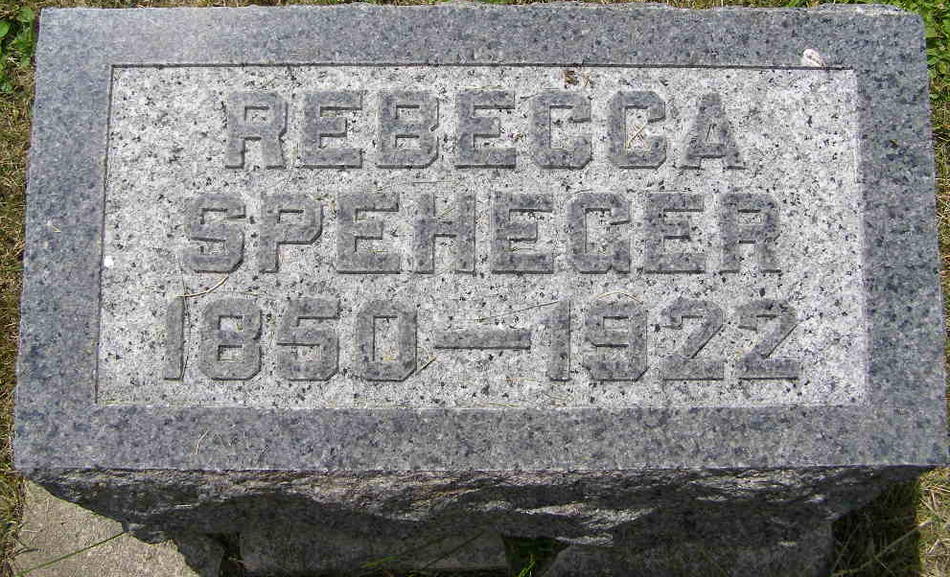
Photo by Shaunda Bedwell Opdycke
Mrs. Abraham Speheger died yesterday at 5 o'clock at the home of her daughter, Mrs. Anna Bowers at Bluffton. Death came after a long illness of diabetes and nephritis. She had been ailing nearly 12 years but was not bedfast until the last three days. Early Friday morning Mrs. Speheger broke an arm while in bed, the bones having become greatly weakened during the long illness.
Rebecca (Fritz) Speheger was born near Livermore, Pa., April 14, 1850, being the daughter of Mr. and Mrs. Jacob Fritz. In 1871, he was married to Abraham Speheger, they having moved to Wayne County, Ohio, soon after. In 1882 they moved to Wells County, Ind., where they lived for many years. Before making her home in Bluffton, Mrs. Speheger lived at Linn Grove for two years. Her husband preceded her in death in 1918. Funeral services will be held tomorrow at 1 o'clock at the Linn Grove Evangelical Church.
Decatur Daily Democrat, Adams County, Indiana
Wednesday, February 15, 1922

