Jesse Jacob Speheger
July 25, 1905 – September 14, 1994

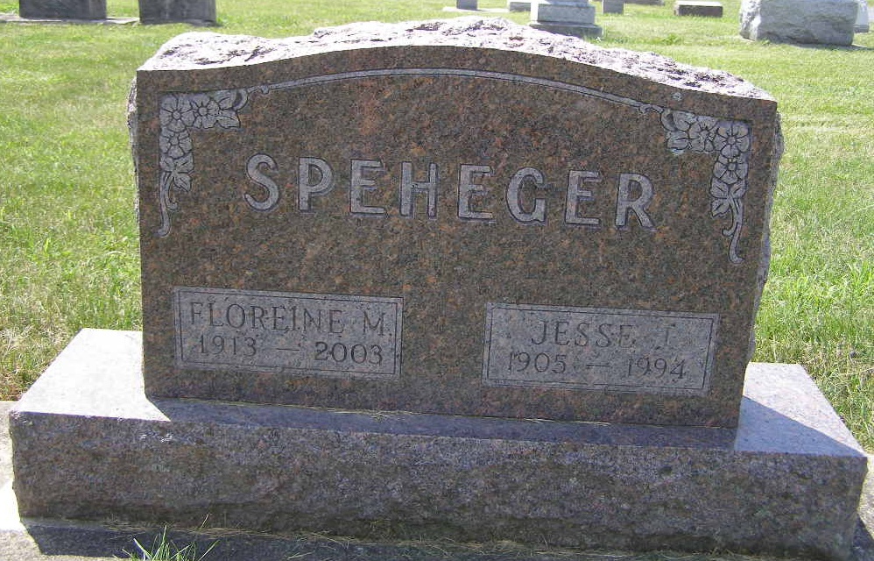
Photo by Shaunda Bedwell Opdycke

JESSE J. SPEHEGER, 89, of Berne died yesterday in Caylor-Nickel Medical Center. The Bluffton native was a retired carpenter. Surviving are his wife, Floreine; a daughter, Deloros Wright of Fort Wayne; a brother, Lloyd of Uniondale; four grandchildren; and six great- grandchildren.
Services are 10 a.m. Saturday in Yager-Kirchhofer Funeral Home, Berne, where calling is 2 to 8 p.m. tomorrow, and 8 to 10 a.m. Saturday. Burial will be in MRE Cemetery.
Preferred memorials are gifts to Swiss Village, Berne.

News-Sentinel, The (Allen County, Indiana)
Thursday, September 15, 1994
**

Indiana, U.S., Death Certificates, 1899-2017

Name Jesse J Speheger
Gender Male
Race White
Marital Status Married
Age 89
Birth Date 25 Jul 1905
Birth Place Berne, Indiana
Death Date 14 Sep 1994
Death Place Bluffton, Wells, Indiana, USA
Death Registration Date 1994
Father John Speheger
Mother Rosa Dubach
Spouse Floreine Habegger Speheger, informant
Burial 9/17/1994 M.R.E. Cemetery

