Floreine M. (Habegger) Speheger
October 11, 1913 – May 12, 2003

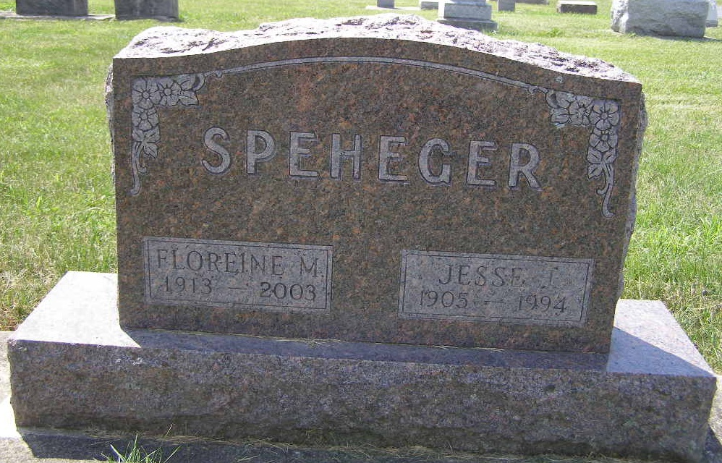
Photo by Shaunda Bedwell Opdycke

Floreine Speheger, 89, Berne, died Monday morning at Swiss Village, Berne. She was the aunt of a Portland resident. Born in Woodburn on Oct. 11, 1913, to Louis and Dina (Sprunger) Habegger, she married Jesse Speheger in Fort Wayne on Dec. 30, 1952. He died in 1994. She was a member of the First Missionary Church, Berne. Surviving are several nieces and nephews, including Rose Cover of Portland.
Services are Thursday at 10 a.m. at Yager-Kirchhofer Funeral Home, Berne, with the Rev. Max Haines presiding. Burial will take place in MRE Cemetery, Berne. Visitation is Wednesday from 6 to 8 p.m. and Thursday one hour prior to services at the funeral home.
Memorials may be made to Swiss Village of Berne.

Commercial Review, The (Jay County, Indiana)
Wednesday, May 14, 2003

