Abraham Speheger
August 4, 1842 – August 12, 1918

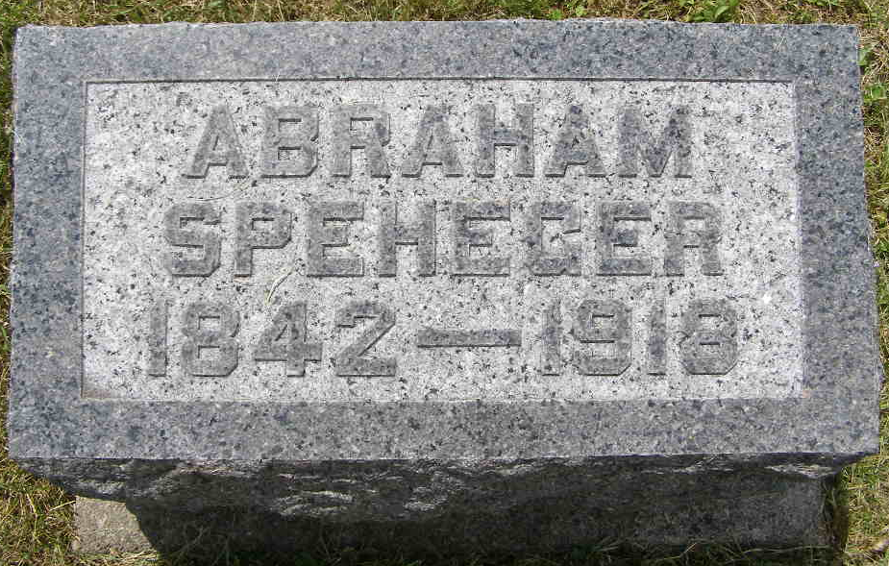
Photo by Shaunda Bedwell Opdycke

Indiana, U.S., Death Certificates, 1899-2017
Name [Abraham Speheger]
Gender Male
Race White
Marital Status Married
Age 76y 8d
Birth Date 4 Aug 1842
Birth Place Switzerland
Death Date 12 Aug 1918
Death Place Linn Grove, Adams, Indiana, USA
Death Registration Date 1918
Father John Speheger b. Switzerland
Mother Fancey Burkhalter b. Switzerland
Spouse Rebecca Speheger
Informant John Speheger
Burial MRE Cemetery 8-14-1918

