William O. Spangler
August 26, 1858 – April 15, 1945

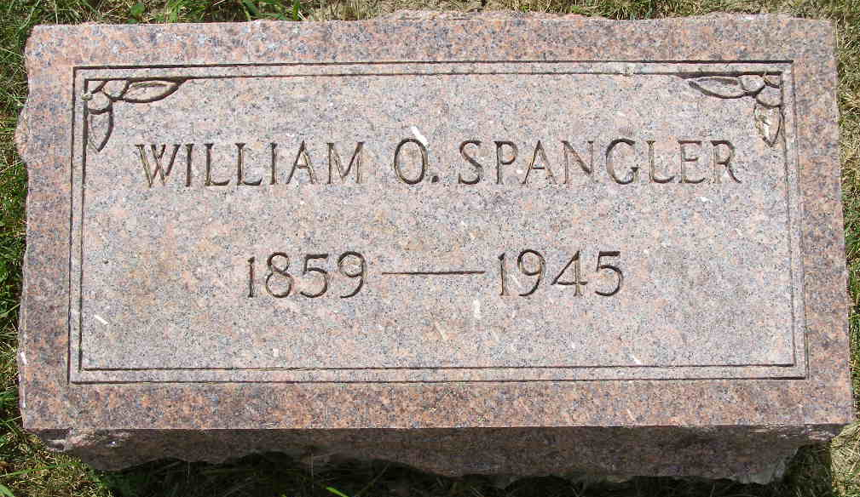
Photo by Shaunda Bedwell Opdycke

Indiana, U.S., Death Certificates, 1899-2017

Name William O Spangler
Gender Male
Race White
Marital Status Widowed
Age 86y 7m 25d
Birth Date abt 1859
Birth Place Center Ohio
Death Date 15 Apr 1945
Death Place Portland, Jay, Indiana, USA
Father Isaic Spangler
Mother Martha Smith
Spouse Laura Spangler
Informant Welfare Dept, Portland
Burial Berne, Ind. 4/19/1945
**

Indiana, U.S., Marriages, 1810-2001

Name William D Spangler
Gender Male
Race White
Age 51
Birth Date 26 Aug 1858
Birth Place Ohio
Marriage Date 3 Feb 1910
Marriage Place Indiana, United States
Residence Place Davidson, Oklahoma
Father Isaih Spangler
Mother Martha Smith
Spouse Laura Clauser
Page 130

