Laura (Clouser) Spangle
June 6, 1875 – May 24, 1916

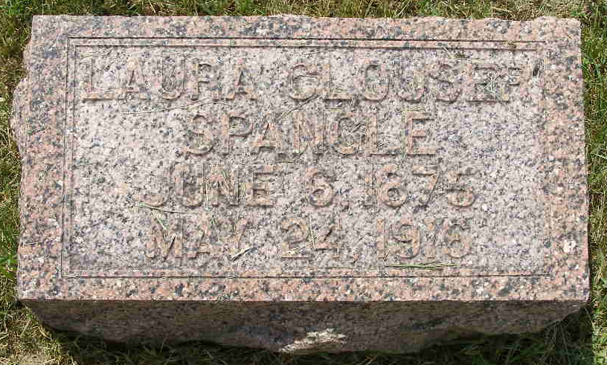
Photo by Shaunda Bedwell Opdycke

Indiana, U.S., Death Certificates, 1899-2017

Name Laura Spangler (indexed as Shangler)
[Laura Spangler]
[Laura Clouser]
Gender Female
Race White
Marital Status Married
Age 41y 4m 15d
Birth Date 9 Jun 1875
Birth Place Indiana
Death Date 24 May 1916
Death Place Fort Wayne, Allen, Indiana, USA
Death Registration Date 1916
Father John Clouser
Mother Mary Coffee
Spouse Wm O Spangler, informant
Burial Berne, Ind. 5/26/1916
**

Biery-Yager Funeral Home Record, Adams County, Indiana
Laura Spangler; Died April 25, 1916 [sic] at Fort Wayne from heart disease; Age 41 years; Body to be shipped from "Wayne"; Funeral May 27, 1916 at Evangelical Church; Burial MRE Cemetery; Funeral home record dated May 25, 1916; Charge to Wm. Spangler; Order given by Wm. Spangler

