Kimberly R. Spade
September 15, 1962 – September 20, 1962

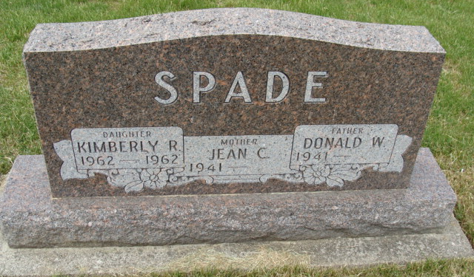
Photo by Alicia Kneuss

SPADE INFANT DIES

The infant daughter, Kimberly R., of Mr. and Mrs. Dona (Jean Gerber) Spade, Geneva rural route two, died last night at the St. Joseph hospital in Fort Wayne, where the child had undergone surgery. The baby, born last Saturday, Sept. 15, was five days old.
Survivors include the parents, a brother Timothy Allen, age 13 months; the grandparents, Mr. and Mrs. Glen Spade and Mr. and Mrs. Robert Gerber, both couples of Geneva rural route two.
Graveside services will be held Saturday morning at 10 o’clock at M. R. E. cemetery with Rev. Harry Reiners and Rev. Armin Steiner officiating.

The Berne Witness, Adams County, Indiana
Friday, September 21, 1962

