Elizabeth (Ebnit) Spade
December 13, 1908 – April 25, 1994

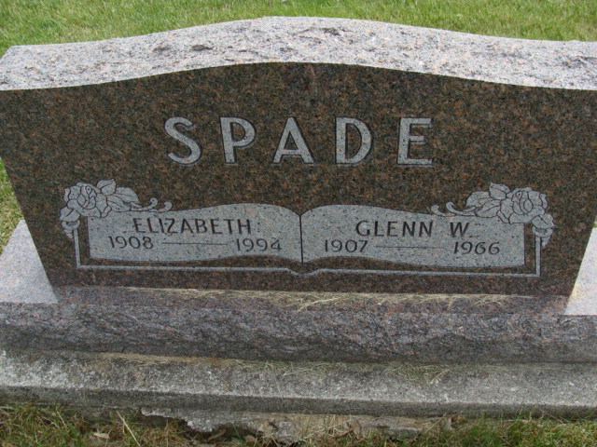
Photo by Alicia Kneuss

ELIZABETH SPADE, 85, of Berne died yesterday in Adams County Memorial Hospital. The Wells County native was the widow of Glenn, who died in 1966.
Surviving are sons, Ronald G. and Donald W., both of Berne; a brother, Melvin Ebnit of New Haven; seven grandchildren; and three great-grandchildren.

Services are 2 p.m. tomorrow in West Missionary Church, Berne, with burial in MRE Cemetery. Calling is 2 to 9 p.m. today, and 9 a.m. to 12:30 p.m. tomorrow in Yager-Kirchhofer Funeral Home, Berne, and 1 to 2 p.m. tomorrow in the church. Preferred memorials are gifts to the church or Swiss Village.

News-Sentinel, The (Allen County, Indiana)
Tuesday, April 26, 1994

