Harvey Elmer Southwood
September 6, 1871 – February 16, 1951

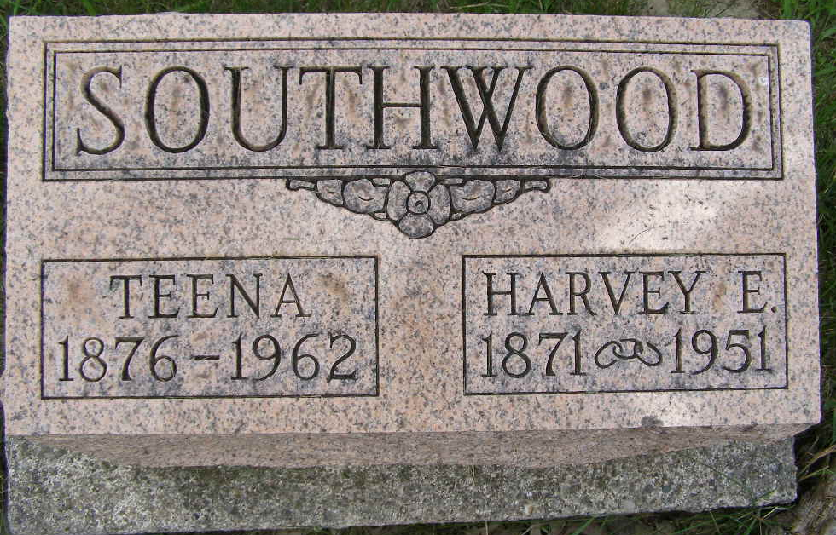
Photo by Shaunda Bedwell Opdycke

Indiana, U.S., Death Certificates, 1899-2017
Name Harvey Elmer Southwood
Gender Male
Race White
Marital Status Married
Age 79
Birth Date 6 Sep 1871
Birth Place Monument City, Indiana
Death Date 16 Feb 1951
Death Place Marion, Grant, Indiana, USA
Death Registration Date 1951
Father Jonas L Southwood
Mother Mellisa Minnick
Informant Mrs. Christena Southwood
Burial 2/28/1951 M.R.E. Cemetery

