Christina ‘Teena’ (Luginbill) Southwood
December 6, 1876 – June 9, 1962

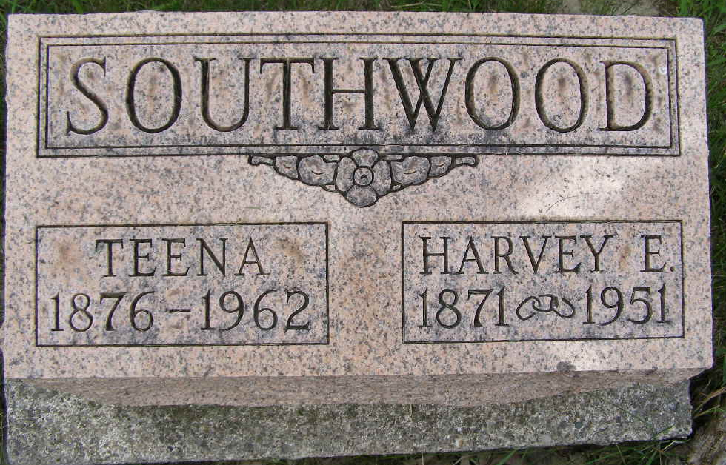
Photo by Shaunda Bedwell Opdycke

Indiana, U.S., Death Certificates, 1899-2017
Name Christina Southwood
[Christina Luginbill]
Gender Female
Race White
Marital Status Widowed
Age 85y 6m 3d
Birth Date 6 Dec 1876
Birth Place Indiana
Death Date 9 Jun 1962
Death Place Greensburg, Dearborn, Indiana, USA
Death Registration Date 1962
Father Christian Luginbill
Mother Mary Ann Moser
Informant Wm. Hamilton, Supt. IOOF State Home
Burial M.R.E. 6-12-1962

