Firsta Viola Sorgen
January 1, 1888 – February 25, 1976

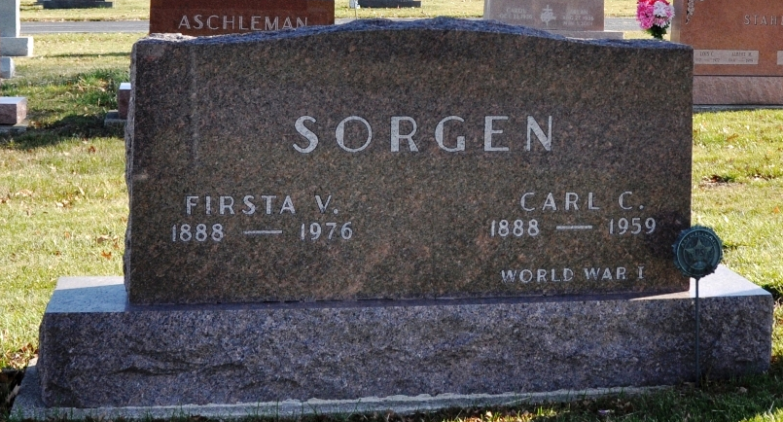
Photo by Deb Curry

Indiana, U.S., Death Certificates, 1899-2017

Name Firsta Sorgen
[Firsta Feasby]
Gender Female
Race White
Marital Status Widowed
Age 88
Birth Date 1 Jan 1888
Birth Place Ohio
Death Date 25 Feb 1976
Death Place Berne, Adams, Indiana, USA
Death Registration Date 1976
Father William Feasby
Mother Aninie Feasby
Informant Chalmer R. Sorgen, son
Burial M.R.E. 2/28/1976

