Chalmer Robert Sorgen
July 22, 1920 – March 20, 2011

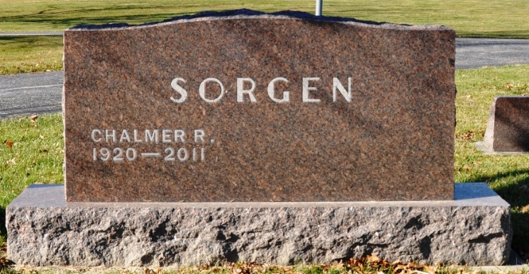
Photo by Deb Curry

Chalmer R. Sorgen, 90, a resident of Berne, Indiana passed away at 1:01 a.m. Sunday, March 20, 2011 at the Adams Memorial Hospital in Decatur, Indiana. Chalmer was born on July 22, 1920 in Allen County, Indiana the son of Carl and Firsta (Feasby) Sorgen, both deceased. He attended the First Mennonite Church in Berne, attended Monroe High School, and was a retired farmer.
Chalmer is survived by a sister, Arleda M. Sorgen of Berne; a niece, Sally Stucky of Fort Wayne; and a niece, Mari Jo Muselman of Phoenix, Arizona.
Chalmer was preceded in death by a sister, Willa Ann Stucky; a brother-in-law, Edward Stucky; a niece, Nancy Stucky, and a nephew, Tom Stucky.
Funeral services will be held at 10:30 a.m. Wednesday, March 23, 2011 at the Yager Kirchhofer Funeral Home in Berne with the Pastor Jeff Linthicum officiating. Interment will be in the M.R.E. Cemetery of rural Berne. Family and friends will be received from 3:00 – 8:00 p.m. Tuesday, March 22, 2011 at the Yager-Kirchhofer Funeral Home and one hour prior to the funeral service at Yager Kirchhofer on Wednesday. Preferred memorials are to the Swiss Village Samaritan Fund.

Yager-Kirchhofer Funeral Home, Adams County, Indiana

