Carl Chalmer Sorgen
March 10, 1888 – August 19, 1959

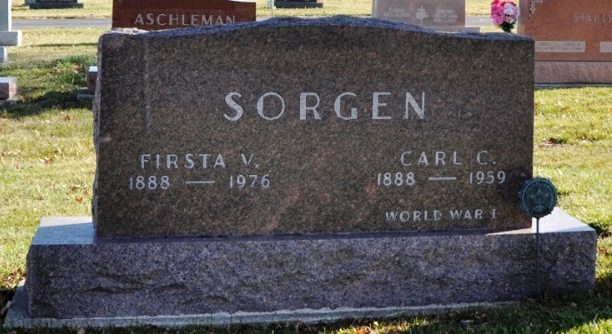
Photo by Deb Curry

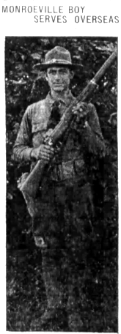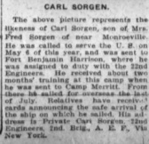
Fort Wayne Journal Gazette, Allen County, Indiana
September 1, 1918, p. 6B

Indiana, U.S., Death Certificates, 1899-2017
Name Carl C. Sorgen
Gender Male
Race White
Marital Status Married
Military WW I veteran
Age 71
Birth Date 10 Mar 1888
Birth Place Hardin County, Ohio
Death Date 19 Aug 1959
Death Place Decatur, Adams, Indiana, USA
Death Registration Date 1959
Father Frederick B. Sorgen
Mother Ruth Fattig
Informant Mrs. Firsta Sorgen
Burial 8/21/1959 M. R. E. Cemetery

