Willis P. Sommer
September 16, 1917 – December 31, 2003

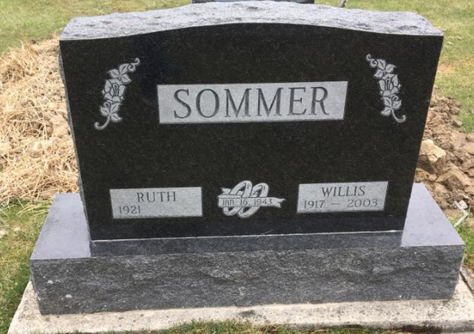
Photo by Shaunda Bedwell Opdycke

Willis P. Sommer, 86

A retired dairy farmer and former member of the Adams County Co-op Credit Union board of directors for 30 years, Willis P. Sommer, 86, of rural Berne, died at 6 a.m. Wednesday, Dec. 31, 2003, at his home. He was a former member of the Monroe Township Advisory Board. He was a member of the First Mennonite Church at Berne.
Born Sept. 16, 1917, in Adams County, he was a son of Abraham and Louise Flueckiger Sommer. His marriage was on Jan. 16, 1943, at Berne to Ruth Steiner, who survives.
Also surviving are two sons, David and Steven Sommer, both of Berne; one sister, Hulda Lehman of Berne; seven grandchildren and three great-grandchildren. He was preceded in death by six brothers, Rufus, Ernest, Otto, Eugene, Amos and Walter Sommer, and three sisters, Louise Wall, Caroline Zumbrum and Johanna Sommer.
Calling will be today from 2 to 8 p.m. at Yager-Kirchhofer Funeral Home, Berne, and on Saturday at the church for an hour before the services. The funeral service will be at 10:30 a.m. Saturday at the First Mennonite Church with Rev. Ray Keim and Harold Nussbaum officiating. Burial will be in M.R.E. Cemetery, Berne.
Memorials to the First Mennonite Church or Family Hospice of Northeast Indiana.

News Banner, Wells County, Indiana
Jan. 2, 2004

