Ruth (Steiner) Sommer
July 3, 1921 – April 30, 2019

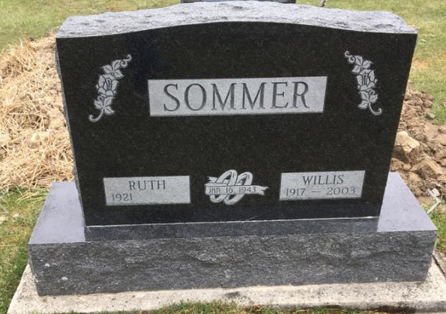
Photo by Shaunda Bedwell Opdycke

Ruth Sommer, 97, lifelong resident of Berne, Indiana passed away Tuesday evening, April 30, 2019, at Swiss Village. She was born on July 3, 1921 in Berne, Indiana to the late Elam and late Fanny (Zurcher) Steiner. She was united in marriage to Willis P. Sommer on January 16, 1943 in Berne and he preceded her in death on December 31, 2003.
Ruth was a faithful member of First Mennonite Church in Berne, where she was a former Sunday School Teacher and avid quilter for the Women’s Ministry Group. She was a former member of the Adams County Homemakers Extension. She was a homemaker and very active assisting on the family farm.
Ruth was a very talented quilter and made each of her grandchildren their own quilt. She enjoyed and was a very talented gardener. She volunteered many hours at Kinder Haus rocking babies, which she was blessed being able to rock some of her own great-grandchildren.
She is survived by two sons, David (Gloria) Sommer of Berne, and Steven (Mary) Sommer of Berne; brother, Rev. LaVerne (Letha) Steiner of Tahlequah, Oklahoma; seven grandchildren, Lisa (Kevin) Girod, Leann (Denny) Schwartz, Lanette (Brent) Buchan, Lance (Nan) Sommer, James (Trina) Sommer, Brandon (Ashton) Sommer, and Justin (Molly) Sommer; and 11 great-grandchildren, Brandi (Luke) Liechty, Brady Girod, Bryan Girod, Conner Schwartz, Makenna Schwartz, Kaine Buchan, Trae Buchan, Hallie Sommer, Landon Sommer, Charlotte Sommer, and Declan Sommer.
Ruth is preceded in death by three brothers, Martin Steiner, Lawrence Steiner, and Willard Steiner.
A funeral service will be held at 10:30 a.m. on Saturday, May 4, 2019, at First Mennonite Church with Pastor Jim Schwartz officiating. Burial will follow at M.R.E. Cemetery. Family and friends will be received from 12:30-2:00 p.m. on Friday, May 3, 2019, at the Swiss Village Chapel and from 3-8 p.m. Friday, May 3, 2019, at the Zwick & Jahn Funeral Home – Yager-Kirchhofer Chapel in Berne and also one hour prior to the service on Saturday.
Preferred memorials are to be made to First Mennonite Church.

Zwick & Jahn Funeral Home, Adams County, Indiana
May 1, 2019

