Otto Karl Sommer
October 25, 1905 – November 4, 1932

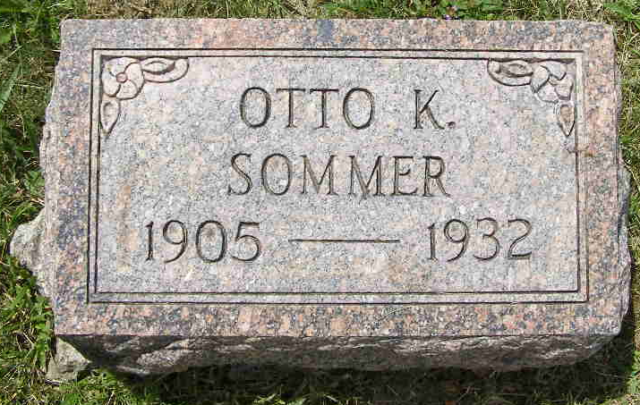
Photo by Shaunda Bedwell Opdycke

Indiana, U.S., Death Certificates, 1899-2017

Name Otto C Somers
Gender Male
Race White
Marital Status Married
Age 27y 8d
Birth Date 25 Oct 1905
Birth Place Switzerland
Death Date 4 Nov 1932
Death Place Decatur, Adams, Indiana, USA
Death Registration Date 1932
Father Abraham Sommers b. Switzerland
Mother Louise Flueckiger b. Switzerland
Spouse Wilma Somers
Informant Mrs. Otto C. Sommers
Burial M.R.E. 11-6-1932
**

Otto Karl Sommer from tree Engle

Birth 27 Oct 1905 Bern, Switzerland
Marriage 24 Dec 1928 Berne, Adams, Indiana, USA
Residence 1930 Adams, Indiana, USA
Death 4 Nov 1932 Decatur, Indiana, USA
Father Abraham Sommer (1874-1932)
Mother Louise Flueckiger (1878-1961)
Spouse Wilma Biberstein (1909-2000)
952 People 7 Records 11 Sources

