Louise (Flueckiger) Sommer
November 15, 1878 – March 16, 1961

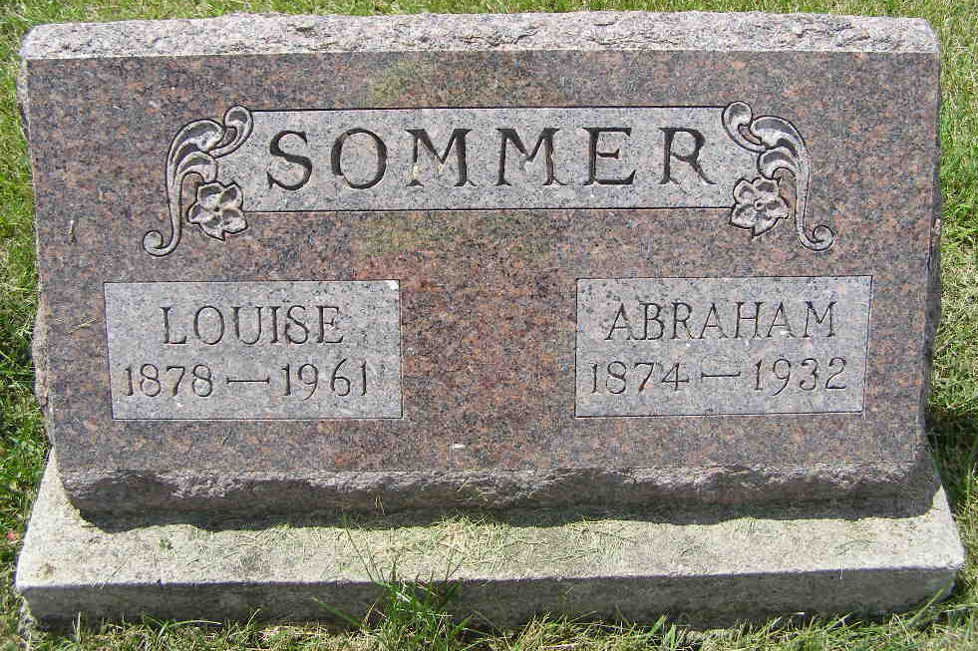
Photo by Shaunda Bedwell Opdycke

Mrs. Louise Sommer Is Taken By Death
Mrs. Louise Sommer, 82, of Berne, died at 2 o'clock Thursday afternoon at the Adams County Community Hospital.
She was born in Canton Bern, Switzerland, Nov. 15, 1878, a daughter of John and Mary Anna Neuenschwander-Flueckiger, and was married to Abraham Sommer in Switzerland March 2, 1901. They came to Adams County in 1907. Mr. Sommer preceded his wife in death in 1932.
Mrs. Sommer was a member of the Berne Cross United Church of Christ.
Surviving are five sons, Walter E. Sommer of Decatur, Eugene J. Sommer of Decatur Route 2, Ernest O. Sommer of Route 2, Cassa???, Otto K. Sommer of Berne Route 2; four daughters, Mrs. J. J. (Louise) Wall of Orland, Calif., Mrs. Harley (Lydia) Lehman of Decatur Route 5, Mrs. Alfred (Caroline) Zumbrum of Berne, and Mrs. Horace (Hulda) Lehman of Berne route 1; 29 grandchildren; 24 great-grandchildren; and two brothers, Theophil Flueckiger of Kidron, O., and Adolph Flueckiger of New London, Ky.
Funeral services will be conducted at 2 p.m. Saturday at the Berne Cross United Church of Christ, the Rev. C. A. Schmid officiating. Burial will be in the MRE Cemetery. Friends may call at the Yager Funeral Home after 3 p.m. today until 12:30 p.m. Saturday, when the body will be taken to the church.
Adams County, Indiana Historical Museum
"1951Jan-Aug1962" Scrapbook; image 18
Handwritten-Fri. March 17, 1961

