Johanna Caroline Sommer
July 8, 1907 – December 21, 1940

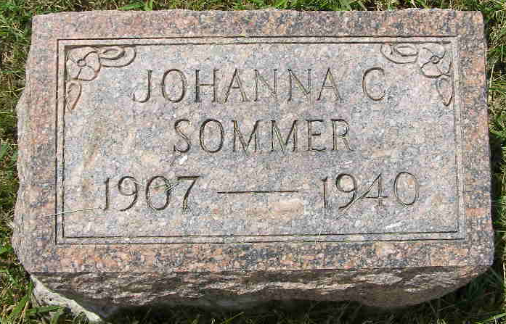
Photo by Shaunda Bedwell Opdycke

FLU CLAIMS MISS JOHANNA SOMMER
Final Rites Will Be Held at Reformed Church Here Tuesday

Miss Johanna Caroline Sommer, 33, died at 7:50 Saturday night at the home of her mother, Mrs. Louisa Sommer two and one-half miles north and two miles east of Berne. She had been ailing four weeks with influenza and complications and was bedfast for seven days.
The decedent was born in Canton Bern, Switzerland, July 8, 1907, and came to this country with her parents at the age of one year. Her father, Abraham Sommer, died in August of 1932 and a brother, Otto, died in November of the same year.
Miss Sommer was a member of the Cross Reformed church here for 17 years and was confirmed while the Rev. Hoerneman served as pastor.
Surviving are her mother; six brothers, Walter Summer of Monroe, Ernest Sommer of Berne, Eugene Sommer of Decatur, Rufus Sommer of near Monroe and Amos and Willis, at home; and four sisters, Mrs. Louise Wall of Orland, Calif., Mrs. Lydia Lehman of Decatur, and Mrs. Caroline Zumbrum and Mrs. Hulda Lehman of Berne.
Funeral services will be held Tuesday at 10 a.m. at the Cross Reformed church here following a brief service at the home at 9:30 o'clock with Rev. C. A. (cut off)

Adams County, Indiana Historical Society
Scrapbook - Image 0171
Handwritten date: Monday, Dec. 23, 1940
**

CARD OF THANKS

We would like to thank all those who so kindly remembered us during our bereavement caused by the recent death of our sister and daughter, Johanna. All your expressions of sympathies were deeply appreciated.
Mrs. Louise Sommer and children

Adams County Historical Museum
1940-1941a Scrapbook, image 05
Handwritten date: Friday, December 13, 1940

