Jacob Sommer
August 24, 1882 – September 14, 1980

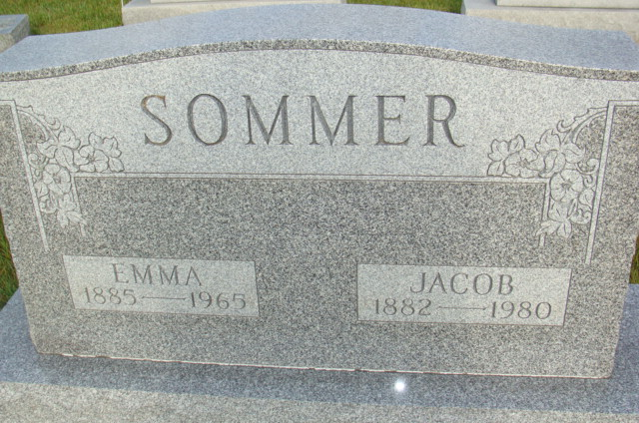
Photo by Alicia Kneuss

Indiana, U.S., Death Certificates, 1899-2017

Name Jacob Sommer
Gender Male
Race White
Marital Status Widowed
Age 98
Birth Date 24 Aug 1882
Birth Place Switzerland
Death Date 14 Sep 1980
Death Place Berne, Adams, Indiana, USA
Death Registration Date 1980
Father Peter Sommer
Mother Katharina Burke
Informant Mrs. Ivan Huser
Burial M.R.E. 9/17/1980

