Isaac A. Sommer
February 16, 1851 – March 19, 1924

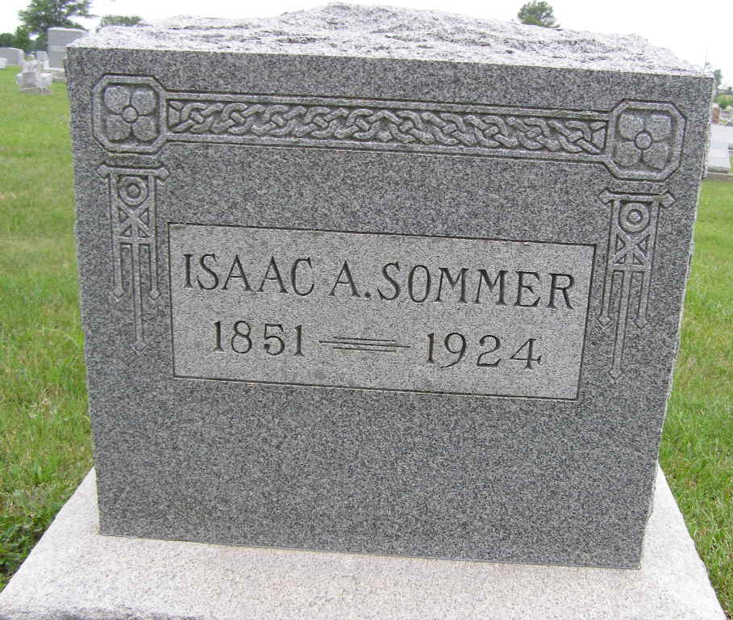
Photo by Shaunda Bedwell Opdycke

Indiana, U.S., Death Certificates, 1899-2017

Name Isaac A Sommers
Gender Male
Race White
Marital Status Single
Occupation Retired Minister
Age 73y 1m 3d
Birth Date 16 Feb 1851
Birth Place Wayne County, Ohio
Death Date 19 Mar 1924
Death Place Berne, Adams, Indiana, USA
Death Registration Date 1924
Father Abraham Sommer
Mother Elizabeth Lehman
Informant J.F. Lehman
Burial MRE cemetery 3/21/1924

