Florine Mildred Sommer
September 29, 1908 – March 16, 1911

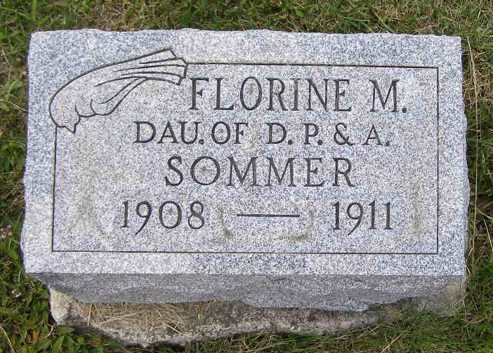
Photo by Shaunda Bedwell Opdycke
DIED
The home of Mr. and Mrs. David P. Sommer was made sad yesterday when their little two and one-half year old daughter, Florine, was plucked from their midst and transplanted to a fairer home above.
Florine Mildred Sommer was born Sept. 29, 1908 and has always been a little ray of sunshine in the home. Last Saturday evening she took sick with inflammation of the bowels and by Sunday morning her fever was up to 105. She grew worse from day to day until yesterday when death relieved her shortly after 11 o'clock.
She leaves her heart-broken parents, two brothers, one sister and a host of other relatives. Funeral will be held Saturday at 1:30 p.m. at the house and at 2 o'clock at the Mennonite church.

Berne Witness, Adams County, Indiana
Friday, March 17, 1911
**

Biery-Yager Funeral Home Records 1910-1916

Lorine[Florine] Sommers; Died March 16, 1911 at Berne from peritonitis; Age not stated; Buried in 40 " casket; Funeral March 18, 1911 at Mennonite Church; Burial MRE cemetery; Charge to David P. Sommers; Order given by David P. Sommers
(Handwritten: Name Florine Mildred Sommers; Born September 29, 1908 Ohio; Age 2 years, 5 months, 17 days; Father David Sommers of Ohio; Mother Adella Sprunger of Indiana

