Ernest O. Sommer
April 14, 1904 – December 12, 1981

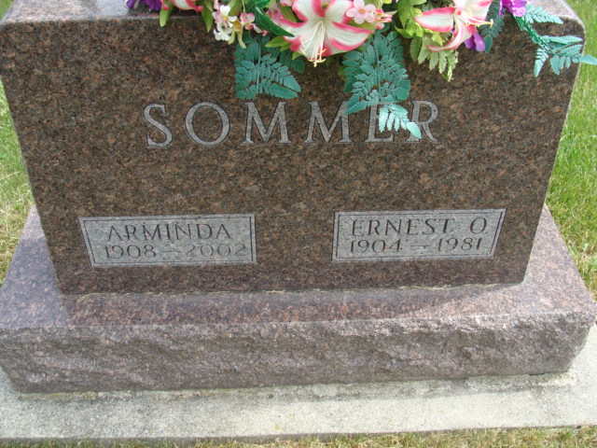
Photo by Alicia Kneuss

Indiana, U.S., Death Certificates, 1899-2017

Name Ernest O Sommer
Gender Male
Race White
Marital Status Married
Age 77
Birth Date 14 Apr 1904
Birth Place Switzerland
Death Date 12 Dec 1981
Death Place Bluffton, Wells, Indiana, USA
Death Registration Date 1981
Father Abraham Sommer
Mother Louise Flueckiger
Spouse Arminda Stucky Sommer, informant
Burial M.R.E. 12/14/1981

