Emma (Kneuss) Sommer
August 12, 1885 – January 1, 1965

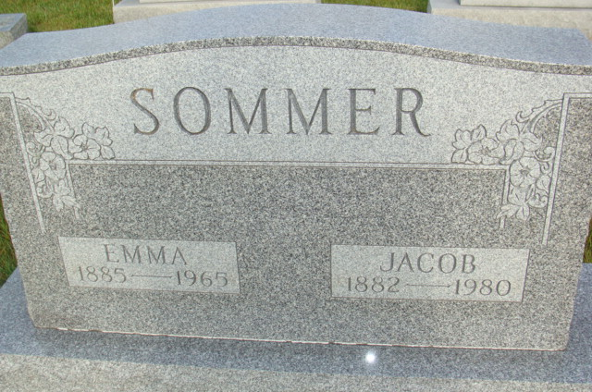
Photo by Alicia Kneuss

Indiana, U.S., Death Certificates, 1899-2017

Name Emma Sommer
[Emma Knauss]
Gender Female
Race White
Marital Status Married
Age 79
Birth Date 12 Aug 1885
Birth Place Indiana
Death Date 1 Jan 1965
Death Place Geneva, Adams, Indiana, USA
Death Registration Date 1965
Father Jacob Kneuss
Mother Anna Zaugg
Spouse Jacob Sommer, informant
Burial 1-3-1965 M.R.E.

