Elmer Herman Sommer
September 25, 1923 – October 16, 1923

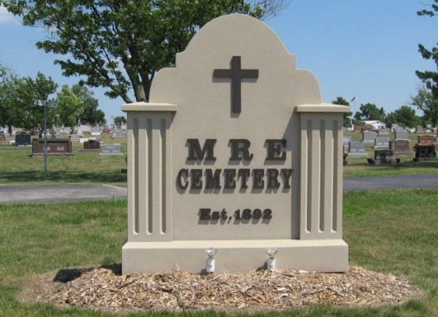
Photo by Tombstoner & Family

Infant Sommer Child Dies

The 21-day-old son, Elmer Herman, of Mr. and Mrs. Jacob Sommer of Wabash Township who had been ailing since birth, was found dead Tuesday morning in his little crib. The child was born with throat trouble which is probably the cause of its death.
Elmer Herman was born Sept. 25th and died October 16th, his age thus being only 21 days. He is survived by his parents and a number of brothers and sisters.
Funeral services were held yesterday afternoon at 2:00 o'clock from the home southeast of Berne.

Decatur Daily Democrat, Adams County, Indiana
Thursday, October 18, 1923
**

Indiana, U.S., Death Certificates, 1899-2017

Name Elmer Herman Sommers
Gender Male
Race White
Age 0
Birth Date 25 Sep 1923
Birth Place Indiana
Death Date 16 Oct 1923
Death Place Wabash, Adams, Indiana, USA
Death Registration Date 1923
Father Jacob Sommers
Mother Emma Kneuess
Informant Jacob Sommers; Geneva, Indiana
Burial October 17, 1923; MRE Cemetery

