David Peter Sommer
February 24, 1877 – February 1, 1954

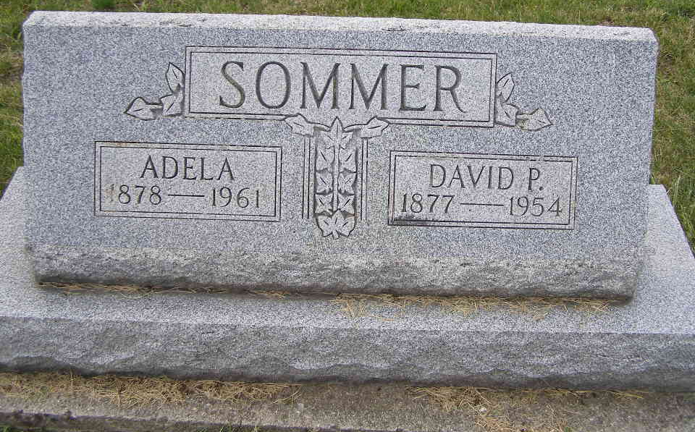
Photo by Shaunda Bedwell Opdycke

Indiana, U.S., Death Certificates, 1899-2017

Name David Peter Sommer
Gender Male
Race White
Marital Status Married
Age 76
Birth Date 24 Feb 1877
Birth Place Ohio
Death Date 1 Feb 1954
Death Place Fort Wayne, Allen, Indiana, USA
Death Registration Date 1954
Father Peter Sommer
Mother Anna Gerber
Informant Mrs. Adela Sommer, Ft. Wayne
Burial 2/4/1954 M.R.E

