Arminda (Stucky) Sommer
December 5, 1908 – January 12, 2002

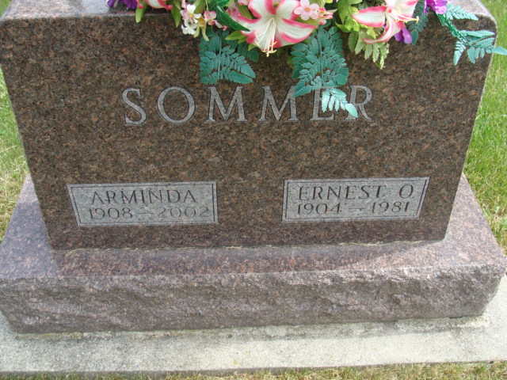
Photo by Alicia Kneuss

Arminda Sommer, 93, of Berne, a member of Cross United Church of Christ, died Saturday, Jan. 12, 2002, at Swiss Village, Berne. The Adams County native retired from Nussbaum Novelty in Berne, Wayne Novelty in Decatur, and Palmer House Restaurant in Berne. She enjoyed quilting.
Surviving are her son, Jerry of Berne; a daughter, Arlene Lehman of Niles, Mich.; six grandchildren; and 11 great-grandchildren. Services are 10:30 a.m. Wednesday at Yager-Kirchhofer Funeral Home, Berne, with calling one-and-a-half hours before services. Calling is also 3 to 8 p.m. Tuesday. Burial will be at M.R.E. Cemetery. Memorials are to Swiss Village.
Information provided by Yager-Kirchhofer Funeral Home, Berne.

News-Sentinel, The (Allen County, Indiana)
Monday, January 14, 2002

