Adela (Sprunger) Sommer
August 12, 1878 – June 6, 1961

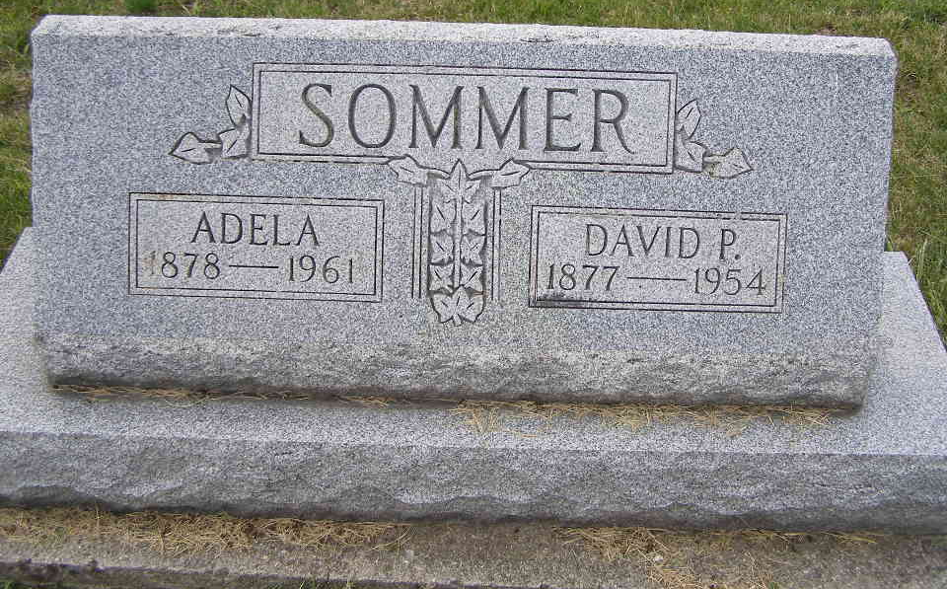
Photo by Shaunda Bedwell Opdycke

Mrs. Adele Sommer Dies At Fort Wayne
Mrs. Adele Sommer, 81, of 3933 South Wayne Avenue, Fort Wayne, died at 3:40 p.m. Tuesday at the Lutheran Convalescent Home, where she had been a patient five months.
She was a native of Berne but had resided in Fort Wayne for 42 years. Her husband, David P. Sommer, died in 1954. Mrs. Sommer was a member of the First Missionary Church in Fort Wayne.
Surviving are two sons, Walter E. Sommer of Fort Wayne, and Lester Sommer of Montpelier; two daughters, Mrs. Dennis Gerig of Fort Wayne, and Mrs. Phillip Smitley of Detroit; 10 grandchildren; nine great-grandchildren; a sister, Mrs. Wilbert Nussbaum of Berne, and a brother, Martin Sprunger of Berne.
Services will be held at 1 p.m. Friday at the First Missionary Church in Fort Wayne, the Rev. Cornelius Vlott officiating. Burial will be in MRE Cemetery at Berne. Friends may call at the Chalfant-Perry Funeral Home after 7 p.m. today until 11 a.m. Friday.
Adams County, Indiana Historical Museum
1951Jan-Aug1962 Scrapbook; image 25
Handwritten-Wed. June 7, 1961
**
Indiana, U.S., Death Certificates, 1899-2011

Name: Adela Sommer
[Adela Sprunger]
Gender: Female
Race: White
Age: 82
Marital status: Widowed
Birth Date: 12 Aug 1878
Birth Place: Berne Indiana
Death Date: 6 Jun 1961
Death Place: Fort Wayne, Allen, Indiana, USA
Father: David Sprunger
Mother: Regina Moser
Informant: Mrs. Denis Gerig; daughter; Fort Wayne, Indiana
Burial: June 9, 1961; MRE Cemetery; Berne, Indiana

