Abraham Sommer
November 30, 1874 – August 2, 1932

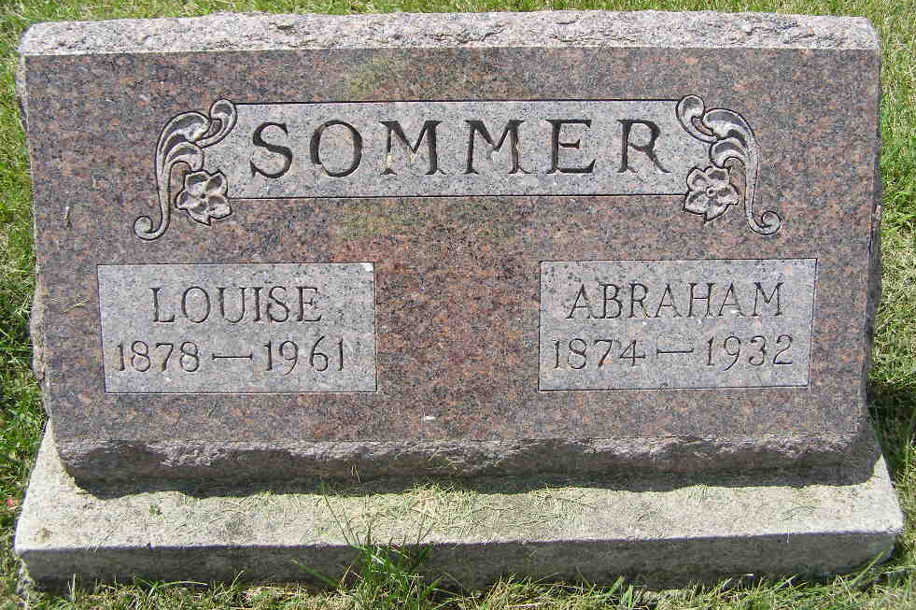
Photo by Shaunda Bedwell Opdycke

Indiana, U.S., Death Certificates, 1899-2017

Name Abraham Sommers
Gender Male
Race White
Marital Status Married
Age 57y 8m 2d
Birth Date 30 Nov 1874
Birth Place Switzerland
Death Date 2 Aug 1932
Death Place Monroe, Adams, Indiana, USA
Death Registration Date 1932
Father Peter Sommers b. Switzerland
Mother Katherine Burke b. Switzerland
Spouse Louise L. Sommers
Informant Mrs. Abraham Sommers
Burial M.R.E. Cemetery 8-4-1932

