William H. Soldner
1892 – May 18, 1897

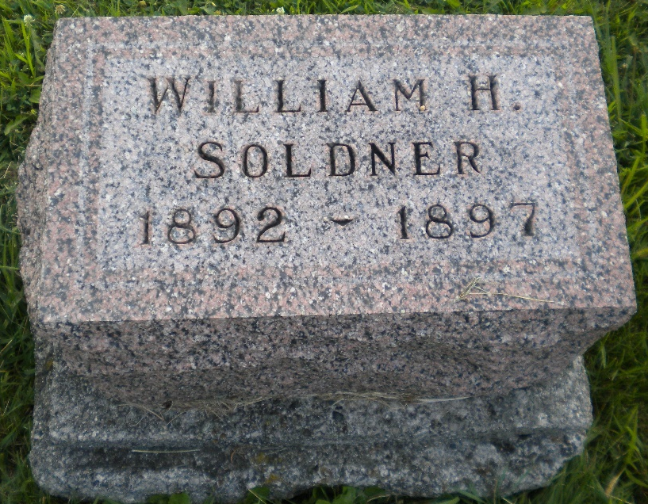
Photo by DSON1492

No further information found at this time.

