Weldon L. Soldner
September 24, 1915 – March 23, 1992

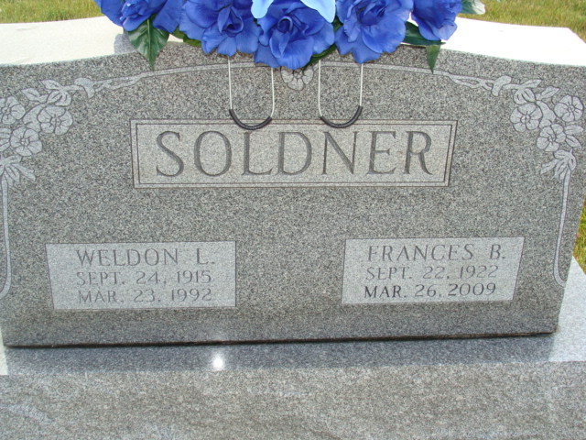
Photo by Alicia Kneuss

Indiana, U.S., Death Certificates, 1899-2017

Name Weldon L Soldner
Gender Male
Race White
Age 76
Marital Status Married
Birth Date 24 Sep 1915
Birth Place Berne, Indiana
Death Date 23 Mar 1992
Death Place Fort Wayne, Allen, Indiana, USA
Death Registration Date 1992
Father Rufus O Soldner
Mother Mary R Balsiger
Spouse Frances M Barkley Soldner, informant
Burial MRE Cemetery, March 26, 1992

