Tilman H. Soldner
May 1, 1887 – May 6, 1979

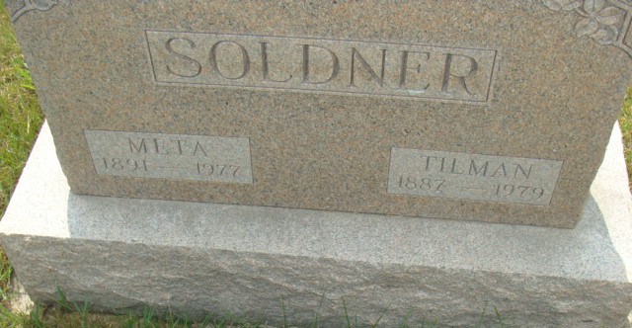
Photo by Alicia Kneuss

Indiana, U.S., Death Certificates, 1899-2017

Name Tilman H. Soldner
Gender Male
Race White
Marital Status Widowed
Age 92
Birth Date 1 May 1887
Birth Place Indiana
Death Date 6 May 1979
Death Place Decatur, Adams, Indiana, USA
Death Registration Date 1979
Father Samuel Soldner
Mother Sarah Gilliom
Informant Brice Bauserman, First Bank of Berne
Burial M.R.E. 5/8/1979

