Sophia (Luginbill) Soldner
February 8, 1868 – May 5, 1949

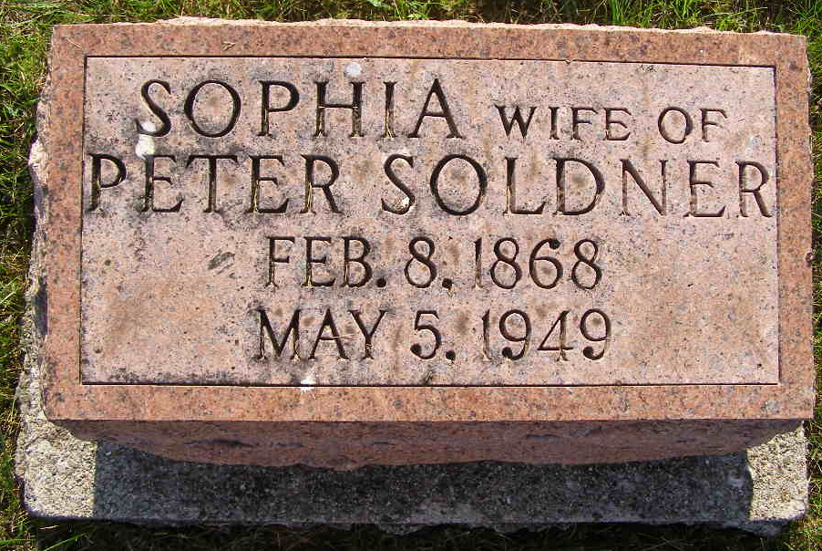
Photo by Shaunda Bedwell Opdycke

Indiana, U.S., Death Certificates, 1899-2017

Name Sophia Emogine Soldner
[Sophia Emogine Luginbill]
Gender Female
Race White
Marital Status Widowed
Age 81y 2m 27d
Birth Date 8 Feb 1868
Birth Place Indiana Berne Indiana
Death Date 5 May 1949
Death Place Fort Wayne, Allen, Indiana, USA
Death Registration Date 1949
Father Christian Luginbill
Mother Amelia Jory
Informant Mrs. Albert Saurer
Burial 5/5/1949 M.R.E.

