Sarah (Zurcher) Soldner
May 10, 1890 – November 3, 1966

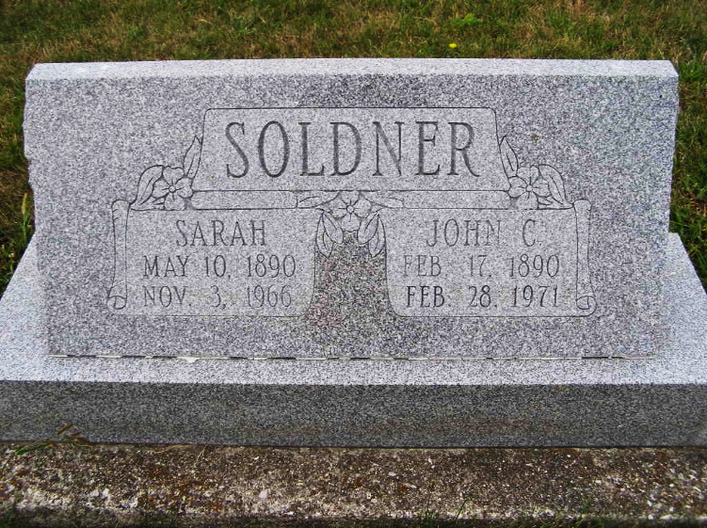
Photo by Shaunda Bedwell Opdycke

Wife of John Soldner Dies Last Evening
Funeral Here Sunday for Monroe Township Woman, 76

Mrs. John (Sarah) Soldner, 76, of route 1, Berne, Monroe Township, who had been living at the Berne Nursing Home for the past two years, died at 5:05, Thursday afternoon at the Adams County Memorial Hospital. Death was attributed to complications. She had been sick for the past three and a half years.
Mrs. Soldner, who was a lifetime resident of Adams County, was born a daughter of Fred and Magdelena Treuhardt Zurcher on May 10, 1890. She was married to John Soldner in Berne on April 16, 1912.
She is survived by the husband; six daughters, Mrs. Rudolph (Florence) Brauner of Anderson; Mrs. Laura Meyer of Berne; Mrs. Glen (Marie) Macy and Mrs. Arthur (Lorena) Covey of Fort Wayne; Mrs. Raymond (Loretta) Brooks of Geneva and Mrs. Verne (Kathryn) Sprunger of Cincinnati, Ohio; three brothers, John Zurcher, Berne; William Zurcher, Monroe and Chris Zurcher of Berne; two sisters, Mrs. Homer (Magdelena) Steiner and Mrs. Martha Johnson; 16 grandchildren and nine great grandchildren. One brother, Fred F. Zurcher and two sisters, Mrs. Mary Bracht and Mrs. Fanny Steiner preceded her in death.
She was a member of the First Mennonite Church where services will be held at 2:00 pm Sunday, November 6, with Rev. Gordon Neuenschwander and Rev. Gerald Stucky officiating. Burial will take place at the MRE Cemetery.

Date of Death: November 6 (sic), 1966 Date of Burial: Sunday, November 6, 1966; Burial on: Lot 349 Original Platt
Berne (IN) Heritage Room
MRE Obits 1966-1972, image 039

