Sarah (Gilliom) Soldner
November 15, 1859 – August 8, 1950

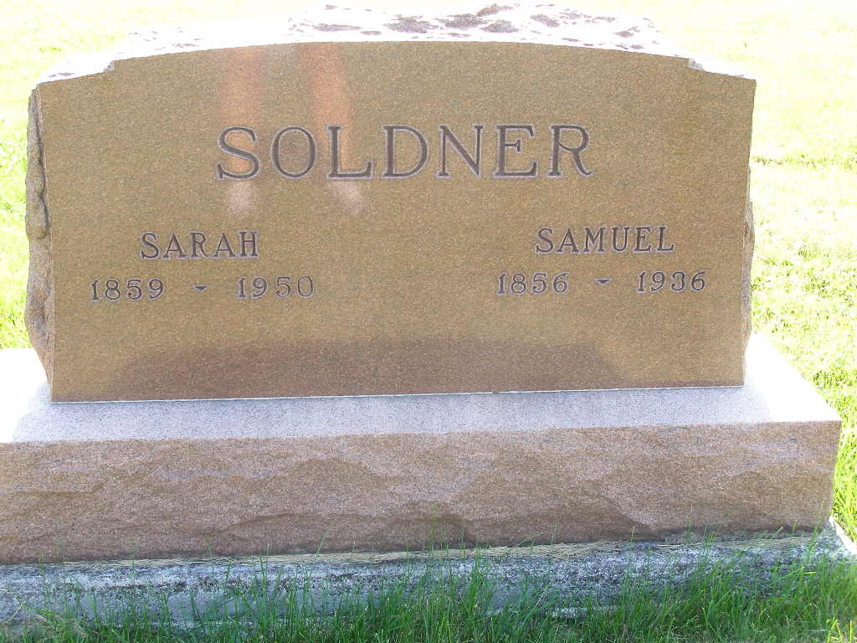
Photo by Shaunda Bedwell Opdycke

Indiana, U.S., Death Certificates, 1899-2017

Name Sarah Soldner
[Sarah Gilliom]
Gender Female
Race White
Marital Status Married
Age 90y 8m
Birth Date 15 Nov 1859
Birth Place Wayne County, Ohio
Death Date 8 Aug 1950
Death Place Berne, Adams, Indiana, USA
Death Registration Date 1950
Father Abraham Gilliom
Mother Anna Hofstetter
Informant Dr. T. H. Soldner, Berne
Burial 8-11-1950 M. R. E. Cemetery

