Samuel Soldner
February 10, 1856 – March 6, 1936

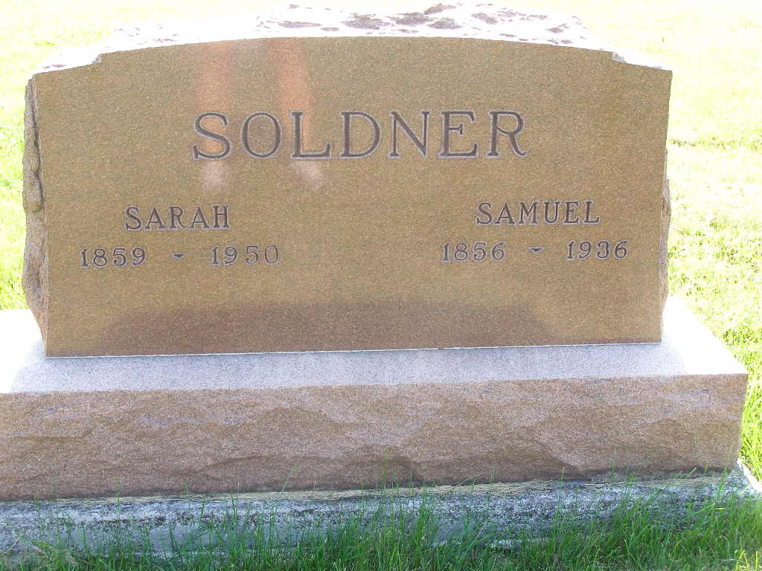
Photo by Shaunda Bedwell Opdycke

DEATH TAKES SAM SOLDNER
Prominent Retired Farmer Dies Here Friday Morning
Samuel Soldner, age 80, highly respected retired farmer of Lehman street passed away at his home at 7:20 Friday morning following several months of failing health and after suffering a stroke at his home last Saturday evening. The direct cause of death was myocarditis.
Mr. Soldner was born on the old Soldner homestead in Wabash township, three miles southwest of Berne, the son of John and Maria Stauffer Soldner. On November 16, 1878 he was united in marriage with Sarah Gilliom by the late Rev. S. F. Sprunger.
After being employed for a period of three years in the Hirschy elevator here and as a clerk in the Marrow store and spending one year in Missouri and three years on the farm owned by his father, Mr. and Mrs. Soldner settled on a farm four miles southeast of Berne. They resided on that farm from 1885 until December 12, 1913. On this farm they reared their family of six children and then retired and moved to Berne in the fall of 1913.
Mr. Soldner had both his legs broken in April 1919 when he was run down by a field roller while assisting Isaac Lehman at the Lehman Park after which he remained a cripple.
Surviving are the widow, six children, Rufus O., Berne; Mrs. Della Neuhauser, Berne; Nora, at home: Dr. Tilman H. of Berne; Wildas H., of Van Wert, Ohio; and Rev Grover T. Soldner of Goshen. He is also survived by two brothers, David of northwest of Berne, and Jonas Fresno, Cal., and one sister, Mrs. Barbara P. Lehman of this place. Twelve grandchildren and two great-grandchildren also survive.
Preceding him were two brothers Peter and John J., and one sister, Mrs. William Baumgartner and one grandchild.
Funeral services were held Sunday afternoon at 1:00 at the home and at 1:30 at the Mennonite church of which he was a lifelong member. Rev. C.H. Suckau officiated and burial was made in the M.R. E. cemetery.

Adams County (IN) Historical Museum
1936 Scrapbook, image 38
Handwritten: Monday, March 9, 1936
**

Indiana, U.S., Death Certificates, 1899-2017

Name Samuel Soldner
Gender Male
Race White
Marital Status Married
Age 80
Birth Date 10 Feb 1856
Birth Place Indiana
Death Date 6 Mar 1936
Death Place Berne, Adams, Indiana, USA
Death Registration Date 1936
Father John Soldner, Alsace Loraine
Mother Maria Stauffer b. Switzerland
Spouse Sarah Gilliom Soldner
Informant Dr. T/L H Soldner
Burial M.R.E. 3-8-1936

