Peter Soldner
February 19, 1860 – September 28, 1921

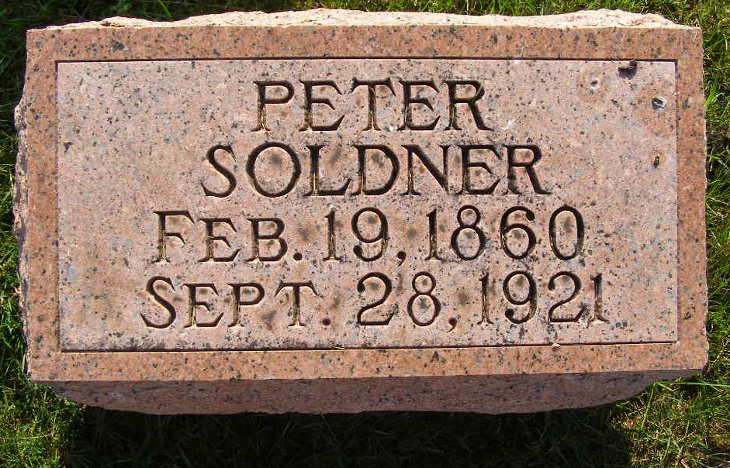
Photo by Shaunda Bedwell Opdycke

Indiana, U.S., Death Certificates, 1899-2017

Name Peter Soldner
Gender Male
Race White
Marital Status Married
Age 61y 7m 9d
Birth Date 19 Feb 1860
Birth Place Wabash Twp, Indiana
Death Date 28 Sep 1921
Death Place Adams, Indiana, USA
Death Registration Date 1921
Father John Soldner b. Alsase Loraine France
Mother Maria Stauffer b. OH
Spouse Sophie Soldner
Informant A. O. Soldner
Burial M.R.E. Cemetery 10/1/1921

