Meta S. (Neuenschwander) Soldner
February 7, 1891 – May 13, 1977

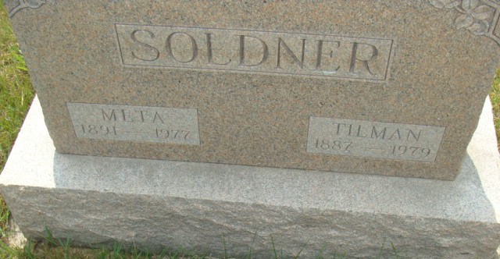
Photo by Alicia Kneuss

Mrs. Soldner

Funeral services were held this afternoon at the Yager Funeral Home for Mrs. Metta Soldner, 86, wife of Dr. Tillman Soldner. Mrs. Soldner died at 8:45 p.m. at the Adams County Memorial Hospital.
??? officiated at the funeral and burial was in the M.R.E. Cemetery.
Mr. and Mrs. Soldner had resided at ?? since January of 1971. Mrs. Soldner had been in failing health and was admitted to the hospital on Tuesday. Death was attributed to a heart attack.
Mrs. Soldner, a lifelong resident of this community was born on February 7, 1891, in Adams County, a daughter of C.A. Neuen-schwander. She married Dr. Tillman H. Soldner, who was a long time local dentist, A???. He survives.
Surviving are two daughters, Mrs. ?? Ruth ??, Pandora, ?? , ??? (Vera) Grimm, Naples, ?? nine grandchildren and ?? great-grand-children, and two ??? Habegger, ?? and Mrs. Ross (Edna) ??? Michigan. A son E?? died in infancy and five ?? (Too hard to figure out what it says)
Preferred memorials are for Swiss Village.

Burial Plot: Lot 332; Date of Death: May 13, 1977

Berne (IN) Public Library Heritage Room
MRE Obits
**

Indiana, U.S., Death Certificates, 1899-2017

Name Meta Soldner
[Meta Neuenschwander]
Gender Female
Race White
Marital Status Married
Age 86
Birth Date 7 Feb 1891
Birth Place Indiana
Death Date 13 May 1977
Death Place Decatur, Adams, Indiana, USA
Death Registration Date 1977
Father C. A. Neuenschwander
Mother Anna Stauffer
Spouse Tillman H. Soldner
Informant Tillman Soldner; husband; Berne, Indiana
Burial May 16, 1977; MRE Cemetery; Berne, Indiana

