Mathilda F. Soldner
March 6, 1883 – September 17, 1904

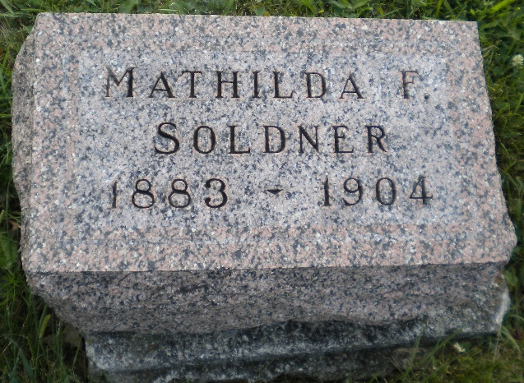
Photo by DSON1492

Indiana, U.S., Death Certificates, 1899-2017

Name Matilda F Soldner
Gender Female
Race White
Marital Status Single
Age 21y 6m 11d
Birth Date 6 Mar 1883
Birth Place Monroe Township, Indiana
Death Date 17 Sep 1904
Death Place Monroe, Adams, Indiana, USA
Death Registration Date 1904
Father John J Soldner, informant
Mother Kathrina Huser
Burial M.R.E. Cemetery 9/19/1904

