Rufus O. Soldner
July 15, 1879 – July 24, 1949

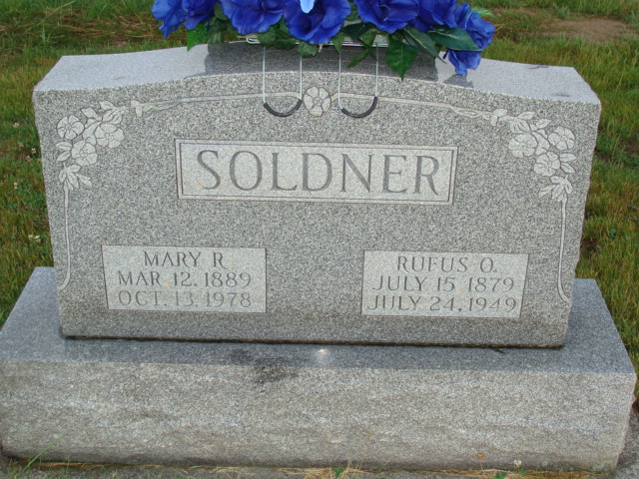
Photo by Alicia Kneuss

RUFUS O. SOLDNER DIES SUNDAY AT FT. WAYNE HOSPITAL
Funeral Here Tuesday for Widely Known Local Man
Rufus O. Soldner, 70, widely known local man, died at 6:25 a.m. Sunday at the Fort Wayne Lutheran Hospital where he had been a patient for several weeks. He had been ailing for two months. Death was caused by a cerebral hemorrhage and complications. Mr. Soldner had been suffering from heart trouble for some time. Mr. Soldner had been in a serious condition for a month and was in a coma part of the time. He, however, appeared slightly improved Saturday but took a sudden turn for the worse during the night.
The deceased was a clothing salesman. He sold for the Van ?? company for 27 consecutive years. Prior to his work as a salesman he was a school teacher in the vicinity for a number of years. He was active in church work and taught a Sunday School class at the First Mennonite Church for more than 25 years before retiring because of failing health.
(Missing) and was married to Mary R. Balsiger , April 30, ?? at Berne.
Surviving is the widow; a son William Soldner, Decatur; a daughter, Miss E?? Soldner, who is in nurses training at the ?? Medical Center in Indianapolis; the mother, Mrs. Sam Soldner, Bluffton, Ohio.
Mr. Soldner was a member of the First Mennonite Church where funeral services will be held at 2:00 p.m. Tuesday, Rev. ?? Clauser officiating. (missing)
Adams County, Indiana Historical Museum
1949June-Oct Scrapbook, Image 29
Handwritten-Mon. July 25, 1949
**

Rufus O. Soldner, 70, brother of W. H. Soldner of Dickinson Avenue and for nearly 40 years associated with the Van Wert Manufacturing Company, died Sunday at the Lutheran Hospital in Fort Wayne. He had been ill about three months, suffering a heart condition.
A native and life-long resident of Berne, Ind., Soldner began to sell products for the local company in 1911, when it was owned by the late Frank Longwell and C. F. Fergus. Since that time, he has been continuously associated with the company as a salesman and in an advisory capacity, playing an important part in the growth of the local firm. In 1929, the Soldner brothers purchased a half interest in the company from Longwell.
Surviving are his wife, Mary; a son, Weldon of Decatur; a daughter, Eloise, a student nurse at the Indiana Medical Center at Indianapolis; two others brothers, Grover of Bluffton and Dr. T. H. Soldner of Berne; two sisters, Nora at home and Mrs. Della Neuhaser of Berne; and his mother, Mrs. Sam Soldner of Berne.
Funeral services will be conducted Tuesday at 2 p.m. at the Mennonite Church at Berne, of which he was a member, with the Rev. A. M. Clauser officiating. Burial will be in the MRE Cemetery. The body has been taken from the Yager Funeral Home to the residence, where friends may call.

Unsourced newspaper clipping

