Marianna (Luginbill) Soldner
March 30, 1863 – March 26, 1891

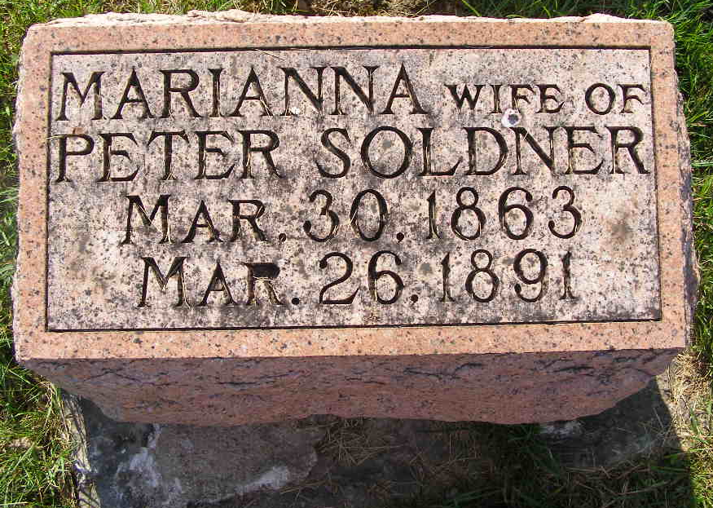
Photo by Shaunda Bedwell Opdycke

Indiana Deaths, 1882-1920

Name M. Soldner
Date Mar 26, 1891
Location Berne
Age 27 Yr
Gender Female
Race White
Source location County Health Office, Decatur
Source notes The source of this record is the book H-19 on page 106 within the series produced by the Indiana Works Progress Administration.
**

Indiana, Marriage Collection, 1800-1941

Name Peter Soldner
Marriage Date 23 Oct 1881
Marriage Place Adams, Indiana, USA
Spouse Name Mary A Luginbill

