Maria (Stauffer) Soldner
January 17, 1820 – January 21, 1907

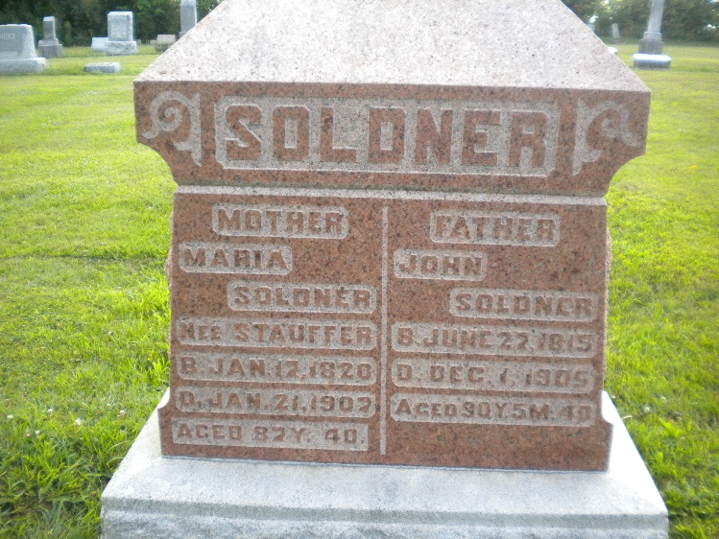
Photo by DSON1492

Ohio, U.S., County Marriage Records, 1774-1993

Name Mary Stauffer
Gender Female
Marriage Date 21 May 1850
Marriage Place Wayne, Ohio, USA
Spouse John Soldner
Film Number 000425754
**

Indiana, U.S., WPA Death Index, 1882-1920

Name Maria Soldner
Date Jan 21, 1907
Location Berne
Age 87 Yr
Gender Female
Race White
Source location County Health Office, Decatur
Source notes The source of this record is the book H-20 on page 6 within the series produced by the Indiana Works Progress Administration.

