John J. Soldner
August 27, 1854 – January 18, 1929
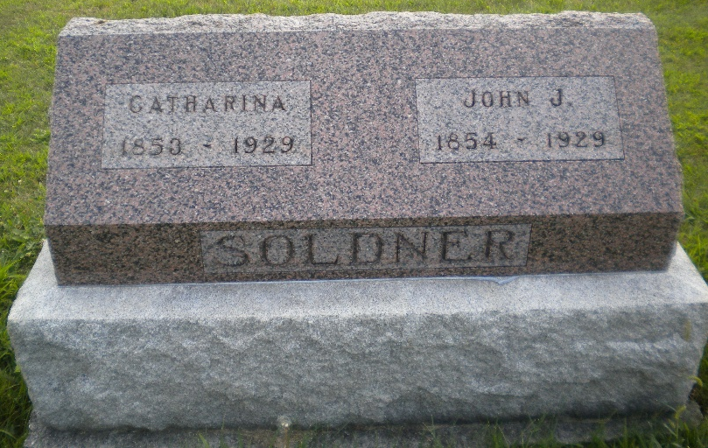
Photo by DSON1492

JOHN J. SOLDNER DIES NEAR BERNE
FORMER ASSESSOR OF ADAMS COUNTY DIES OF CANCER
John J. Soldner, 74, former Adams County Assessor, died of cancer at 2:15 o'clock Friday morning at his home four miles northwest of Berne. Mr. Soldner has been bedfast since November 7, a sufferer from cancer.
He was born in Wabash Township, Adams County, August 28, 1854.
He served four years as trustee of Monroe Township, two terms as Adams County Assessor and one term as deputy county assessor.
Surviving are the widow, Catherine Huser Soldner; one daughter, Mrs. C. O. Moser, of Geneva; two sons, John C. Soldner at home and Noah G. Soldner of Pandora, Ohio; three brothers, David and Samuel Soldner of Berne and Jones Soldner of Fresno, Calif; and two sisters; Mrs. Barbara Lehman and Mrs. William Baumgartner of Berne.
Funeral services will be held at the Mennonite Church in Berne at 2 o'clock Monday afternoon with burial in the M. R. E. Cemetery west of Berne.

Bluffton Evening News, Wells County, Indiana
Saturday, January 19, 1929, p. 1, col. 1

