John Calvin Soldner
February 17, 1890 – February 28, 1971

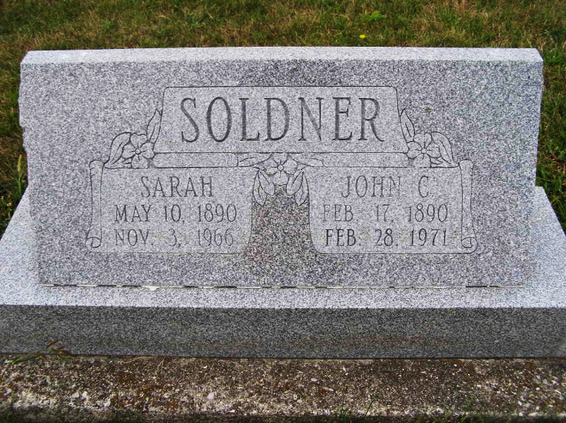
Photo by Shaunda Bedwell Opdycke

John C. Soldner, Retired Farmer, Dies Sunday
Brief Illness Fatal to Monroe Twp. Native, 81, Rites Tuesday

John C. Soldner, 81, a retired Monroe Township farmer and a resident at Swiss Village the past two years, passed away at 3:00 am Sunday at the Adams County Memorial Hospital following a short illness.
Mr. Soldner was found to be ill Friday morning when he failed to appear for breakfast. Investigation in his room was made and he was found ill in bed. He was taken by ambulance to the hospital where he died Sunday morning. He had previously been in his usual health.
During his life, Mr. Soldner always manifested keen interest in community and church activity and at one time served on the Monroe Township Advisory Board.
He was born on February 17, 1890, in Monroe Township where he spent his entire life. He was a son of John J. and Katherine Huser Soldner. In 1912 he was married to Sarah Zurcher, who preceded him in death in 1966.
Surviving are five daughters, Mrs. Rudolph (Florence) Brauner of Anderson; Mrs. Laura Meyer of Berne; Mrs. Glen (Marie) Macy and Mrs. Arthur (Lorena) Covey of Fort Wayne; Mrs. Raymond (Loretta) Brooks of Geneva and Mrs. Verne (Kathryn) Sprunger of Cincinnati. There are also a sister and a brother who survive: Mrs. Prudentia Mosser of Muncie and Noah N. Soldner of Goshen. Mr. Solder also had 16 grandchildren and 13 great-grandchildren.
Mr. Soldner was a member of the First Mennonite Church where services will be held in the chapel at 2 pm on Tuesday with Rev. Gordon Neuenschwander and Rev. Gerald Stucky officiating. Burial will be in the MRE Cemetery.

Date of Death: February 27, 1971; Date of Burial: March 2, 1971
Burial: Lot 519, Original Platt

Berne (IN) Library Heritage Room
MRE Obit Book 1966-1972
**

John C. Soldner taken by death
John C. Soldner, 81, of Swiss Village, a retired Adams County farmer, died at 3 a.m. Sunday at the Adams County Memorial Hospital, where he had been a patient for two days.
A son of John J. and Katherine Huser-Soldner, he was born in Monroe Township Feb. 17, 1890. His wife, the former Sarah Zuercher, preceded him in death in 1966. Mr. Soldner was a member of the First Mennonite Church.
Surviving are six daughters, Mrs. Rudolph (Florence) Brauner of Anderson, Mrs. Laura Meyer of Berne, Mrs. Glen (Marie) Macy and Mrs. Arthur (Lorene) Covey, both of Fort Wayne, Mrs. Raymond (Loretta) Brooks of Geneva, and Mrs. Vern (Kathryn) Sprunger of Cincinnati, O.; one sister, Mrs. Prudentia Mosser of Muncie; one brother, Noah N. Soldner of Goshen; 16 grandchildren and 12 great-grandchildren. Three sisters and one brother are deceased.
Services will be held at 2 p.m. Tuesday at the First Mennonite Church Chapel, with Rev. Gordon Neuenschwander and Rev. Gerald Stucky officiating. Burial will be in the MRE Cemetery. Friends may call at the Yager Funeral Home in Berne after 2 p.m. today.
Decatur Daily Democrat, Adams County, Indiana
Monday, March 1, 1971

