John Soldner
June 27, 1815 – December 1, 1905

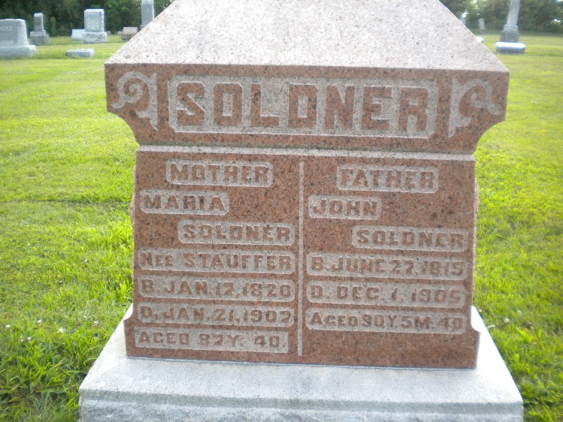
Photo by DSON1492

Indiana, U.S., Death Certificates, 1899-2017

Name John Soldner
Gender Male
Race White
Marital Status Married
Age 90
Birth Date 27 Jun 1815
Birth Place France
Death Date 1 Dec 1905
Death Place Berne, Adams, Indiana, USA
Death Registration Date 1905
Father unknown
Mother Barbara Frere
Spouse Marin Soldner
Informant Peter Soldner
Burial MRE Cem. 12/4/1905

