Frances B. (Barkley) Soldner-Hammond
September22, 1922 – March 26, 2009

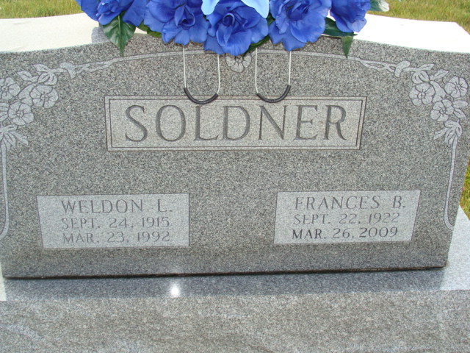
Photo by Alicia Kneuss

Frances B. (Soldner) Hammond, 86 years old of Kokomo, Indiana, passed away on Thursday, March 26, 2009 in the St. Vincent Hospital located in Indianapolis. She was born on Friday, September 22, 1922 in Van Wert County, Ohio the daughter of Orley S. and Garnetta G. (Arnold) Barkley. She married her first husband, Weldon L. Soldner on October 24, 1943 in Decatur and he passed away on March 23, 1992. She married her second husband, Robert H. Hammond on July 13, 1996.
Frances was a member of the First Baptist Church in Decatur and the Ladies Society of the church. She also taught Sunday school for many years.
Surviving are her husband, Robert H. Hammond of Kokomo, daughter, Rebecca (Robert) McClure of Decatur, daughter, Janice (Rev. Maurice) Grindle of Rochester, daughter, Linda (Ross) Busch-man of Decatur, son, David (Julie) Soldner of Decatur, step-son, Philip (Chris) Hammond of Tempe, Arizona, step-daughter, Judy (Ken) Otto of Kokomo, step-son, Tim (Lorrie) Hammond of Indianapolis, step-daughter, Yee Yee (Greg) Kuhn of Indianapolis, sister, Vonola (Roger) Myers of Fort Wayne, ten grandchildren, six great-grandchildren, eleven step-grandchildren and five step great grandchildren.
Preceding Frances in death were one brother, James Barkley, one sister, Lois Strickler, one son, Robert L. Soldner and one grandson who both died in infancy.
Funeral services will be held at 10:00 a.m. Tuesday, March 31, 2009 in the Zwick & Jahn Funeral Home with Dr. Robert Stuck and Rev. Robert Adelsberger officiating. Interment will follow in the M.R.E. Cemetery, Berne, Indiana. Friends will be received from 2 p.m. to 8:00 p.m., Monday, March 30 in the Zwick & Jahn Funeral Home, Decatur. In lieu of flowers memorials may be made to the First Baptist Church Missions Program or the Local Chapter of Youth for Christ. Serving as pallbearers will be Aaron R. McClure, Travis A. McClure, Andrew D. Grindle, Joel M. Grindle, Matthew M. Highstrom, Caleb Z. Soldner, Joshua Z. Soldner and Isaac Z. Soldner.

Zwick & Jahn Funeral Home, Adams County, Indiana

