Gertrude (Lehman) Soldner
December 7, 1896 – January 16, 1969

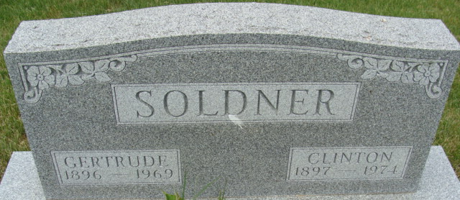
Photo by Alicia Kneuss
Gertrude Soldner Dies at Berne Home

Mrs. Clinton (Gertrude) Soldner, 72, of 318 West Wabash, Berne, died at 8:07 a.m. Thursday at her home in that city. She had been ill since Nov. 16. She was born in Monroe Township Dec. 7, 1896, a daughter of Ulrich and Judith Sprunger-Lehman, and was married to Clinton Soldner Nov. 29, 1917.
Mrs. Soldner, who served as a cook at the Berne Nursing Home for 11 years, was a member of the First Mennonite Church.
Surviving in addition to her husband are two daughters, Miss Janet H. Soldner, R.N. of Bogota, Columbia, South America, and Mrs. Roger (Treva) Schaffter of Berne Route 1; three brothers, Omer Lehman of Decatur, Wesley Lehman of Decatur, and Horace Lehman of Berne Route 1; two sisters, Mrs. Elmer (Elizabeth) Lehman of Berne, and Mrs. Ervin (Laura) Canen of Modesto, Calif., and two grandchildren. One brother and three sisters are deceased.
Services will be held at 10 a.m. Monday at the Yager Funeral Home in Berne, with Rev. Gordon Neuenschwander officiating. Burial will be in MRE Cemetery. Friends may call at the funeral home after 11 a.m. Sunday.
Preferred memorials are to the mission to Mennonites in Bogota, Columbia.

Decatur Daily Democrat, Adams County, Indiana
Friday, January 17, 1969
**

Indiana, Death Certificates, 1899-2011

Name: Gertrude Soldner
[Gertrude Lehman]
Gender: Female
Race: White
Age: 72
Marital status: Married
Birth Date: 7 Dec 1896
Birth Place: Indiana
Death Date: 16 Jan 1969
Death Place: Berne, Adams, Indiana, USA
Father: Ulrich Lehman
Mother: Judith Sprunger
Spouse: Clinton Soldner, Informant
Burial: MRE 1-20-1969

